Introduction to Python Programming for Biologists

5-day Workshop

8-12 April 2019

Room 2005
Perold building
Stellenbosch

Bring your Own Notebook Computer

Contents
Contents 2
Introduction 4
Data structures 5
Bytes 5
Hexadecimal 6
Big-endian and little-endian 7
Memory 7
A series of instructions 7
Install Python 3.x 8
Python is an interpreter 8
Install PyCharm 9
Launch PyCharm 9
Comments in code 13
Variables 13
Operators 14
Equality and assignment operators 15
Bitwise and logical operators 16
Data Types 17
Strings 17
Exercises Day 1 21
Lists, tuples, sets and dictionaries 25
Data Input and Output 30
Input from the keyboard 30
Reading data from a file 30
Manipulating bits and bytes in Python 32
Representation of Characters 33
Writing data to a file 35
Exercises Day 2 37
Loops 41
The for-loop 41
Enumerate 42
Nested loops 42
The while-loop 43
Conditionals 44
If, elif, else 44
Exercise Day 3 46
Functions 50
Simple Functions 50
Variable Scope 51
Recursive functions 53
Classes 55
Classes 55
Inheritance 57
Containers and Iterations 58
Assignment Day 4 60
Modules 63
Importing modules 63
Numpy 64
Exceptions 68
Debugging 71
Breakpoints and conditional breakpoints 72
Single stepping 73
Assignment Day 5 74
Appendix 80
File formats 80
fastA 80
fastQ 81
Generic Feature Format version 3 (GFF3) 82

Introduction
This workshop introduces you to Python 3 for programming in the biological sciences. This is presented over 5 days, and includes exercise sections to test your mastering of concepts encountered on each day. By the end of day 4, you will have developed to a point where you can code a modest program, and your practical assignment will be to code a program that can read a multi sequence fastA format file, and calculate the AT% of each sequence in the file.
On day 5 you are given a slightly more challenging assignment where you will read the sequences of the 17 Saccharomyces cerevisiae chromosomes (including the mitochondrial chromosome), using your fastA program from day 4, but will then also read information from a GFF format file of gene features that specifies the location of all genes in the S. cerevisiae genome. You will use this information to select all yeast gene sequences and calculate the frequency of all possible triplet codon sequences in the gene encoding sequences.
At this point, this may sound incredibly complex, but it is not! This course will provide you will all the coding knowledge that you will need to code the programs for the day 4 and day 5 exercises. In addition, this course will provide you with a solid programming foundation in Python 3 to write many programs that you can use in your own scientific research, and from which you can grow and gain experience to become a bioinformatician or scientific programmer. This is the era of Big Data, and it is essential in the biological sciences to be able to code. Once you are comfortable with using Python 3, it will be relatively easy to also learn other languages such as Java or C/C++.
This course is carefully structured to introduce concepts in an order required to understand successive ideas as we build upon levels of sophistication, and to provide insight into basic concepts that will enhance your understanding of programming as we go along. Enjoy the course! Remember, with a computer, tinkering and trying things are encouraged!

Data structures

Bytes
Humans count in units of 10, probably because we have 10 fingers.
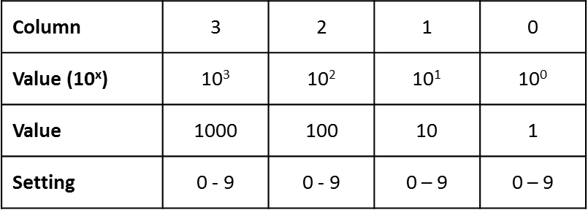
Fig. 1. Humans count in a base 10 system. When column 0 of value 1 contains 9 dots it is “full”. If you add a tenth dot, you need to add one dot to the column 1 of value 10, and remove the 9 dots from column 0.
Computers represent numbers using small hardware switches called transistors. The transistors can only be on or off, it cannot be one of 10 (0 to 9) different states. For this reason, computers “count” in base 2.

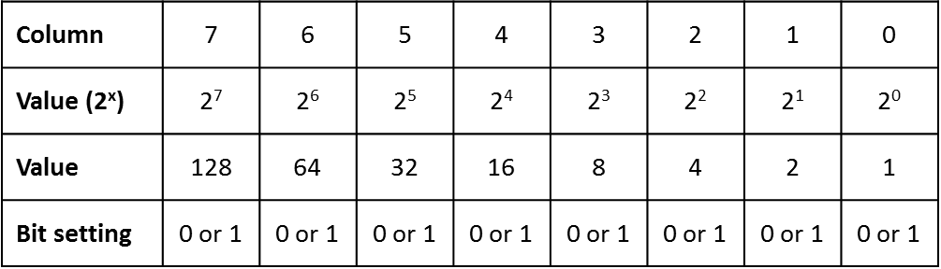
Fig. 2. Use the base 2 system to count using computer transistors. Like the base 10 scheme, where columns represent 1 (10⁰), 10 (10¹), 100 (10²), the base 2 (or binary) scheme represents 1 (2⁰), 2 (2¹), 4 (2²), 8 (2⁴), etc. The value of a bit (“binary information unit”; 0 or 1) depends on its position. In column 0 a bit represents 0 or 1, in column 1 it represents 0 or 2, in column 3, 0 or 4, etc.
Note
The value of a set bit (bit that is “on”) in a column is one greater than the sum of the maximum values of all the columns to the right. This is, of course, identical to the base 10 system (see Fig. 1) where, say, 100 is 1 greater that the maximum setting (99) for column 1 (10s) and column 0 (1s).
The 8 columns (0 - 7), representing 8 bits is known as 1 byte. The terms for other groups of bits are shown in Table 1.
Table 1. The largest integer number that can be represented by different numbers of bits, and the term for each collection.
Number of bits | Largest number represented | Term
4 | 15 | nibble
8 | 255 | byte
16 | 65,535 | word
- | 1,024 | kilobyte (KB)
- | 1,048,576 | megabyte (MB)
- | 1,073,741,824 | terabyte (TB)
64 | 1.845×10¹⁹ | -

Hexadecimal
An additional counting system that is often encountered in computing is base 16, or the hexadecimal system. The individual “number” in a group of 16 is represented by 0-9 continuing with the letters A, B, C, D, E and F, thus 0-F.
Note
You need 4 bits to represent 16 different values (see Fig. 2). Thus, each byte of 8 bits can be represented by 2 hexadecimal numbers. Each hexadecimal number represents a nibble. Examples of hexadecimal representations are shown in Table 2. It is useful to know that if all 8 bits are set in a byte, the number represents decimal 255, which is equivalent to hexadecimal FF. If all bits in a 64 bit number is set, the hexadecimal representation would be FFFF FFFF FFFF FFFF. It is convention to write each 16 bit value as a hexadecimal block for clarity.

Table 2. The decimal, binary and hexadecimal representation of some numbers.
Decimal value | Binary value | Hexadecimal value
15 | 00001111 | 0F
32 | 00100000‬‬‬‬‬‬‬‬‬‬‬‬ | 20
204 | 11001100‬‬‬‬‬‬‬‬‬‬‬‬‬‬‬‬‬‬‬‬‬‬‬ | CC
255 | 11111111 | FF
65,535 | 1111111111111111‬‬‬‬‬‬‬‬‬‬‬‬ | FFFF

Big-endian and little-endian
When you have a number represented by more than one byte, say 8CDF, the order of the bytes becomes important. For instance, hexadecimal 8CDF is 36063 in decimal, but the reverse DF8C is 57228. You therefore must have a system that defines whether the higher value byte (8C) is written first or last. There are two possibilities, called big-endian and little-endian, based on the Lilliputians in Gulliver’s Travels who argued whether an egg should be broken at its “little end” or “big end”. The big-endian system defines that the high value byte comes first. You would typically not have to worry about this when you program -- the operating system takes care of it. But if you read and write multi-byte values or floats to memory, you must know whether the memory arrangement is big- or small-endian.

Memory
Memory is typically a range of locations, where each location has a unique address (Fig. 3). Each memory locations can typically store 64 bits of information. The largest 64 bit number that can be stored is 9,223,372,036,854,775,807 although there is no upper limit to an integer in Python.
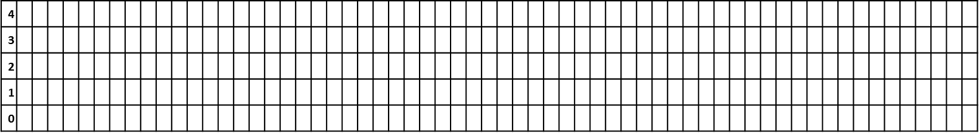
Fig. 3. Memory is composed of a number of 64 bit locations, where each location has a unique address, here indicated as 0, 1, etc.

A series of instructions
A computer program is simply a list of instructions that is executed by a computer. This is similar to explaining the route from the town square parking lot to your favorite restaurant:
- At the parking lot pedestrian exit, cross the street to the opposite sidewalk.
- Turn left.
- Continue walking until you are at the traffic light.
- If the light is green, cross to the opposite sidewalk.
- Turn right.
- Walk and count 35 steps.
- Turn left.
- You are now in front of your favorite restaurant.
Although this is a mundane set of instructions, it contains several features found in real computer programs. In step 3, you continue doing something until a condition is met: you are at a traffic light. In step 4, you do something if something is true: the lights is green. In step 6, you repeatedly execute an action: you take 35 steps. As you will see later in this practical, a computer program typically also repeats a series of instructions a number of times or until a condition is met, and will also execute a series of instructions only if a certain condition is True (or False).
At a very low level, instructions would be reading the contents of one or more memory locations, copying the contents to the CPU, doing something with those values, and storing the result back to another memory location. However, high level languages such as Python or Java or C++ allows you to write instructions that look more like the instructions describing the route to the restaurant, than operating on the content of memory locations. However, it is useful to know what happens “under the hood”, so that programming does not become detached from the functioning of the computer.
Python was originally developed by Guido Van Rossum, and released in February 1991. Its name is derived from the BBC comedy series “Monty Python’s Flying Circus”. One of the most famous Monty Python routines is the Dead Parrot Sketch. Python is an interpreted, object-oriented programming language, incorporating modules, exceptions, dynamic typing, very high level dynamic data types, and classes.
There are many excellent sources of help on the Internet that you can turn to for assistance. Make use of these when you work through this practical. Bookmark the official Python documentation and the Python tutorial and refer to these for additional help. You can also refer to the following books:
- Lubanovic, B. Introducing Python. O’Reilly Media Inc. 2014 ISBN-13: 978-1449359362
- Ramalho, L. Fluent Python. O’Reilly Media Inc. 2015 ISBN-13: 978-1491946008
- Lutz, M. Learning Python. O’Reilly Media Inc. 2013 ISBN-13: 978-9351102014

Install Python 3.x
You can install the latest version of Python 3 on Windows, MacOS or Linux by downloading and installing the binaries from www.python.org. Full installation instructions are given on the web site. There are several documents, guides and forums accessible on the website where you can get advice if you struggle.
Note
Python 3.x is already installed on the Narga lab computers.

Python is an interpreter
Computer programs can be executed in one of two ways: the program can be compiled, which means that a compiler processes the entire series of instructions, and generates a series of low level instructions that is executed by the CPU. An example of a compiled language is C and C++. The advantage of a compiled language is that the compiled code generally executes very fast, and this type of program is therefore well suited to computation-intensive tasks.
An interpreted program is taken one line of instruction at a time, translated to a low level code that is executed by the CPU. Interpreted languages typically execute slower, but is more convenient to learn, because the program can be executed by passing it to the interpreter, and does not need to go through a compilation step, that requires time.
Thus, for an interpreted language like Python you would write a series of (meaningful) instructions in a text file, and then provide this text file to the python interpreter to interpret and execute. For instance, if you program file was called “my_program.txt”, you would execute it with the command:
>python my_program.txt
However, writing programs in text files, and passing it to the python interpreter in command line is tedious. It is much easier to use an application development environment where you can write, test, debug and run your program without having to leave the development application. One example of such an application is PyCharm. We will be using PyCharm extensively in this practical.
Note
PyCharm is already installed on the Narga lab computers.

Install PyCharm
You can download the “Community Edition” (free) of PyCharm from www.jetbrains.com/pycharm. There are versions for Windows, macOS and Linux. Full installation instructions are given on the Jetbrains website.

Launch PyCharm
Find the PyCharm icon on the start menu, and launch the program.
Fig. 4. Making a new project in PyCharm.

Select File | New Project from the menu. In the resulting window that open, enter a project name (“helloworld” in this example) to the end of the path. Next, select the “Project Interpreter” item in the same dialog box.
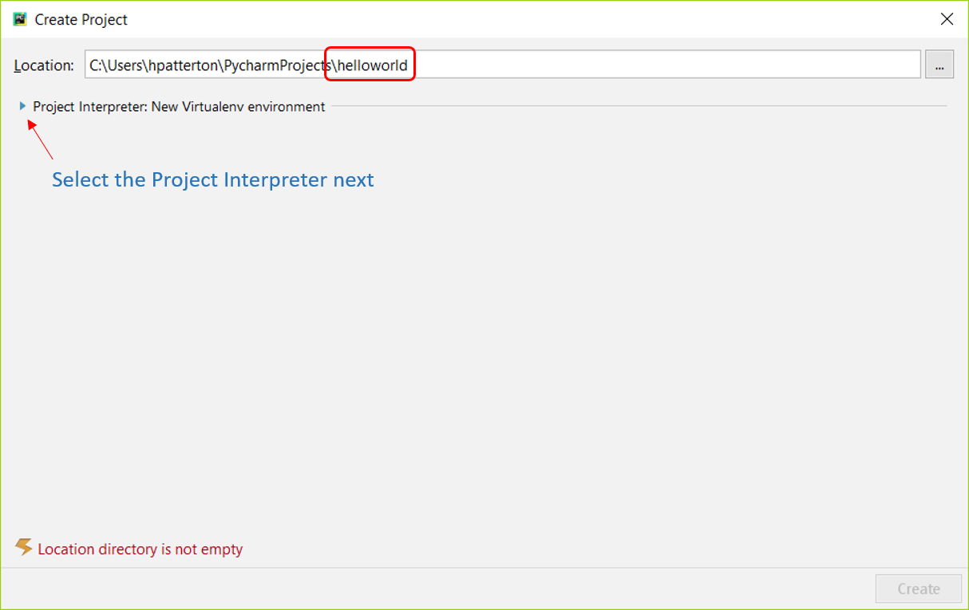
Fig. 5. Naming the new project.
In the resulting dialog box, select “Existing Interpreter” and the most recent version of Python 3.x available on your computer in the drop-down list box.
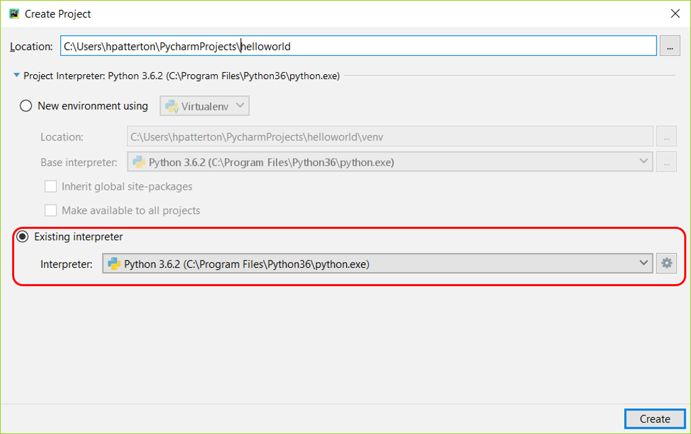
Fig. 6. Selecting the interpreter.
The PyCharm program should now look like this. The left panel is the Project panel, and will contain a list of projects that you are working on. Currently it should have a single entry helloworld.

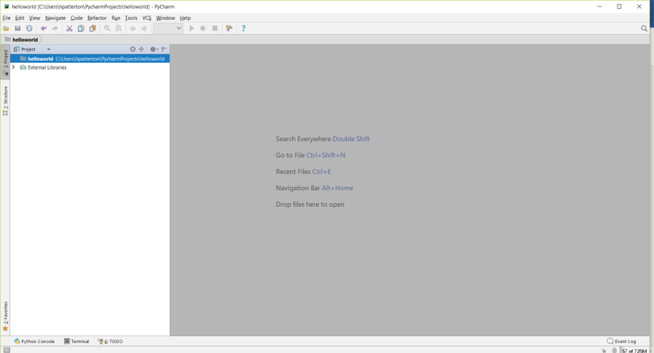
Fig. 7. The project window.
Click on File | New… on the menu, and then select Directory.
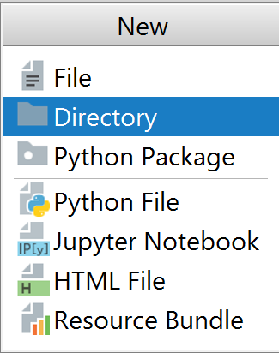
Fig. 8. Making a new directory for the project code
Enter source as new directory name
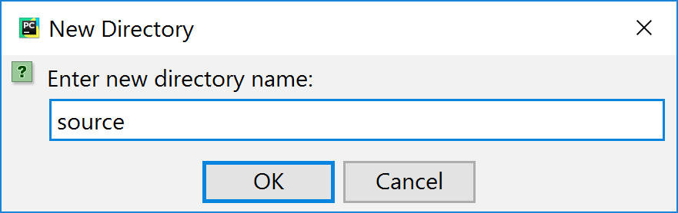
Fig. 9. Naming the new directory.
Right click on the source directory icon that appeared in the Projects panel, and select New and File from the pop-up menu (you can also select New and Python File).
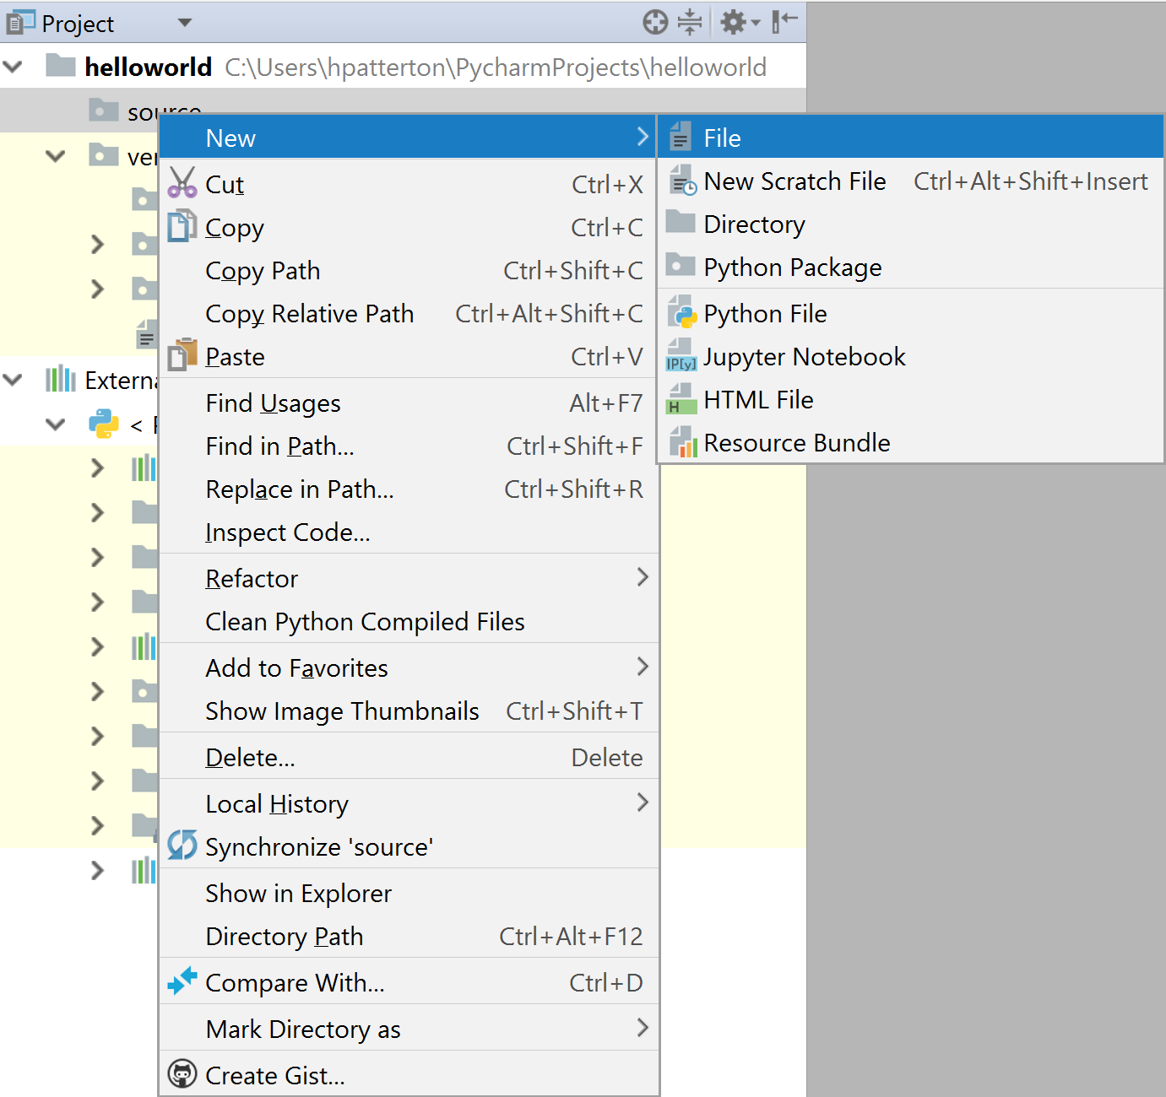
Fig. 10. Making a new code file.
Call the new Python file helloworld.py in the resulting dialog window. It is good practice to call the main code file of your program the same name as your program. Python files that contain text code should always be named with the .py extension. If you select Python File from the dialog box, the .py extension is automatically added. The new helloworld.py file will immediately open in the editor panel of PyCharm.
In the helloworld.py editor window, type the text:
print("Hello world!")
Select Run and Run from the menu, and Run and Run from the resulting dialog windows
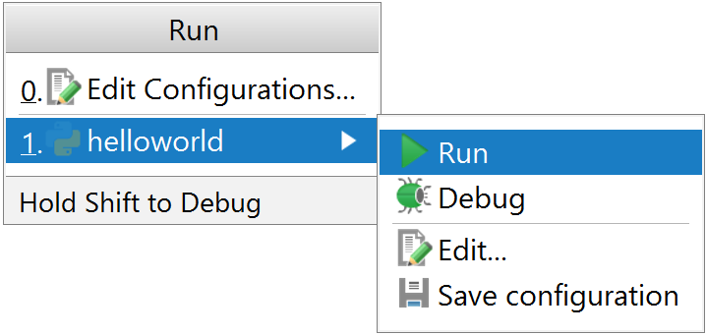
Fig. 11. Run helloworld.py.
A new window will appear at the bottom of the PyCharm editor, the terminal window, and the following text should be displayed in this window:
C:\Users\hpatterton\PycharmProjects\helloworld\venv\Scripts\python.exe C:/Users/hpatterton/PycharmProjects/helloworld/source/helloworld.py
Hello world!

Process finished with exit code 0

Note that the first line in the output is the path to the Python interpreter program, followed by the path to the helloworld.py file, which was passed to the interpreter. The Python interpreter stepped though the text in helloworld.py, line by line, interpreting and executing each line until it runs out of lines. In the case of helloworld.py this did not take long, since there was only one line. The program produces the output “Hello world!”. The interpreter then reports that it has finished with exit code 0. This means that there were no errors.
The command print() is an example of an built-in function. There are many commands that are available in Python to perform important, general tasks.
You can save your file helloworld.py, and close the Project if you wish. You can open the project again to continue to work on it immediately, or the next time that you launch PyCharm.

Comments in code
The Python interpreter ignores all text following the “#” character up to the next newline character. Thus you can add notes or comments to yourself in your code by starting the comment with a “#” character. For example:
# The section of code below reads the data from file
or
print(“Hello world!”) # This line prints a message for the user
Unlike the “/*” and “*/” pair in C++, Python does not have a multi-line comment mark. Thus you have to start each line of a comment block with a “#” character, if you want to add multiple consecutive lines of comment. Note that in PyCharm you can select a block of code, and then insert a “#” at the start of each selected line from the menu Code > Comment with Line Comment. If you select one or more lines starting with a “#”, you can remove (toggle) the “#” character (uncomment the code) by again selecting Code > Comment with Line Comment from the menu.
Use comment lines in your code. It makes reading and understanding the code much easier, especially if another programmer has to add to code that you wrote.

Variables
A variable is the name for an object that can contain a value or information such as text. In other languages such as C++ that require strict typing, you must declare a variable before you can assign a value to it. The compiler thus knows what types of values may be assigned to a variable. In Python, the type of a variable is determined by the interpreter from the value that is assigned to a variable. Thus, in Python, there is no need to declare a variable; you simply assign a value to it. For instance, if you want to assign the value 3 to the variable a, simply write:
a=3
Make a new PyCharm project called variables, add a file called variables.py, and enter the following lines of code into the editor window:
a=3
print(a)
Select Run and Run from the menu, and then variables and Run from the pop-up menu. The output is produced in the terminal window (for brevity we ignore the path to the interpreter and the code file, as well as the exit code):
3
In the remainder of this manual we will indicate the output of a print() statement in the terminal window as a comment on the same line of code to improve readability, as in:
print(a) # 3
In this case, we have set a to an integer (whole number). We can also set a to a float (a number with a fraction):
a=2.5
print(a) # 2.5
Variable names need not be single letters. It can be alphanumeric (letters or numbers) and upper or lower case. The only exception is that variable names cannot start with a number.
abc123 = 5 # this is OK
1a = 3 # this is not allowed
It is good coding practice to use variable names that describe the data that they contain, for example
number_of_sequences = 200 # underscore helps to increase readability
numberofsequences = 200 # difficult to read
NumberOfSequences = 200 # difficult to read
remaining_iterations = 150
Descriptive variable names make it easier for other coders to understand and work with your code, and it also makes it easier for you to return to your code a year after having written it, and to continue to work on it.
Variables can be used in numeric operations.
a = 2.5
b = 3
c = a + b
print(c) # 5.5
A variable is equal to the last value assigned to it:
a = 2
a = 5
print(a) # 5

Operators
The following operators are available in Python
Table 3. Python 3 operators
Operator | Use | Example¹
+ | Adds values on either side of the operator | a + b = 7
- | Subtract right-hand operand from left-hand operand | a - b = 3
* | Multiplies values on either side of the operator | a * b = 10
/ | Divides left-hand operand by right-hand operand | a / b = 2.5
% | Modulo. Returns remainder after division of left-hand operand by right-hand operand. | a % b = 1
** | Exponent | a ** b = 25
// | Integer division/Floor division. The fraction is discarded after division. If either operand is negative, the answer is rounded away from zero (floored). | a // b = 2  -a // b = -3
¹a = 5 and b = 2

The operator precedence is as generally used in mathematics:
Table 4. Operator precedence.
Precedence | Operator
1 | **
2 | *, /, %, //
3 | +, -
4 | <=, <, >, >= (comparison)
5 | ==, != (equality)
6 | =, %=, /=, //=, -=, +=, *=, **= (assignment)

Equality and assignment operators
The <=, <, > and >= operator is used to compare the magnitudes of the left-hand and right-hand operands, returning True if the magnitudes matches the relationship tested by the operator. The equality operators == and != (not equal) functions in the same way. The value True or False can be assigned to a variable known as a Boolean type variable (bool), named after the English mathematician George Boole, who contributed important work to algebraic logic.
Table 5. Equality operators
Operator | Meaning
< | Less than
<= | Less than or equal
> | Greater than
>= | Greater than or equal
== | Equal
!= | Not equal

The assignment operators, in addition to =, are shorthand operators for assignments.
Note
= is used to assign a value to a variable as in a = 1. The equality operator == is used to test value equality, such as in the statement a == 1. If the value of a is 1, the statement a == 1 returns True, otherwise it returns False. Try not to confuse assignment = with equality ==. It is the biggest source of bugs in noob code.

Table 6. Assignment operators
Assignment operator | Shorthand use | Meaning
%= | a%=b | a = a%b
/= | a/=b | a = a/b
//= | a//=b | a = a//b
-= | a-= b | a = a - b
+= | a+=b | a = a + b
*= | a*=b | a = a*b
**= | a**=b | a = a**b

The += operator is very useful if you want to increment a variable by one. If you write a loop to repeat a set of instructions (see later), and need to increment the variable a by one every time you complete the loop, you can simply write
a += 1
This is shorthand for a = a + 1
This may look strange. It is not an algebraic expression. It is Python code. What the interpreter does is take the current value of a in memory, add 1 to that value, and then write the incremented value of a to the same memory location. The incrementing of variables is extensively used in code.
Note that spaces surrounding operators are irrelevant.
a + b is the same as a + b is the same as a+b.
Spaces are, however, critical to indicate the start and end positions of loops or functions (more about that later).
You can explicitly cast a variable to a desired type by making use of float() or int() to ensure you are working with what you want to be working with:
a = 2
b = float(a)
c = int(b)
print(a) # 2
print(b) # 2.0
print(c) # 2

Bitwise and logical operators
There are several bitwise and logical operators that are very handy in programming. A bitwise operator is an operator that is applied to bits.
Table 7. Bitwise operators
 |  | and | or |  | exclusive or | not¹
 |  | Symbols in Python
Bit 1 | Bit 2 | & |  | | | ^ |  | ~
0 | 0 | 0 |  | 0 | 0 |  | 1
1 | 0 | 0 |  | 1 | 1 |  | 0
0 | 1 | 0 |  | 1 | 1 |  | 1
1 | 1 | 1 |  | 1 | 0 |  | 0
¹not is a unitary operator. It works on a single operand (here bit 1)

These bitwise operators can obviously also be applied to series of bits found in bytes and in wider binary numbers:
11001101 (=205)
OR 11000011 (=195)
________
11001111 (=207)
In Python logical operators work like bitwise operators, except that it is applied to expressions that return True or False values. Note that in Python, unlike C++, the logical operators are not abbreviated as &&, || etc., but as the words and, or etc.
Table 8. Logical operators.
Condition 1 | Condition 2 | and | or | not¹
False | False | False | False | True
True | False | False | True | False
False | True | False | True | True
True | True | True | True | False
¹not is a unitary operator, applied to a single condition (condition 1 here)

Data Types

Strings
A string is a collection of one or more characters, and is enclosed in single or double quotes when assigned. It does not matter whether you use single or double quotes – choose a convention and stick to it.
a = "This is a string"
print(a) # This is a string
You can “add” (concatenate) strings:
a = "This is a string"
b = " and another string"
c = a + b
print(c) # This is a string and another string
You can also ‘repeat’ a string:
my_string='bla'*5
print(my_string) # blablablablabla
A string is immutable. That means that once a string literal (characters enclosed in quotation marks) has been assigned to a variable, the string cannot be modified. However, the variable can be reassigned. The following is perfectly legal:
a = "If she weighs the same as a duck..."
a = a + " she's made of wood."
print(a) # If she weighs the same as a duck... she's made of wood.
There are many functions that can be applied to strings.
For instance to convert all the letters in a string to uppercase, use the name_of_string.upper() function. The way is which this is written may appear odd at first. The reason why the function is written after the variable name using a point, followed by the function name, is because the function is a member function or method of the string class, and our specific string is an instantiation of that string class. All member functions are called with a point notation relative to the instantiated class. If this makes little sense now, do not worry, we will delve into classes and objects later.
a = "This is a string"
a = a.upper()
print(a) # THIS IS A STRING
We can also find the number of letters in a string (or members in an iterable object – see later):
a = "So why do witches burn?"
print(len(a)) # 23
Table 9. String functions that are frequently used. See the Python documentation at https://docs.python.org/3/ for a full list of functions.
Methods with Description | Methods with Description
capitalize() | Capitalizes first letter of string
count(str, beg= 0,end=len(string)) | Counts how many times str occurs in string or in a sub-string of string if starting index beg and ending index end are given.
endswith(suffix, beg=0, end=len(string)) | Determines if string or a sub-string of string (if starting index beg and ending index end are given) ends with suffix; returns true if so and false otherwise.
expandtabs(tabsize=8) | Expands tabs in string to multiple spaces; defaults to 8 spaces per tab if tabsize not provided.
find(str, beg=0 end=len(string)) | Determine if str occurs in string or in a sub-string of string if starting index beg and ending index end are given returns index if found and -1 otherwise.
isalnum() | Returns true if string has at least 1 character and all characters are alphanumeric and false otherwise.
isalpha() | Returns true if string has at least 1 character and all characters are alphabetic and false otherwise.
isdigit() | Returns true if string contains only digits and false otherwise.
islower() | Returns true if string has at least 1 cased character and all cased characters are in lower-case and false otherwise.
isnumeric() | Returns true if a unicode string contains only numeric characters and false otherwise.
isspace() | Returns true if string contains only white-space characters and false otherwise.
isupper() | Returns true if string has at least one cased character and all cased characters are in upper-case and false otherwise.
len(string) | Returns the length of the string
ljust(width[, fillchar]) | Returns a space-padded string with the original string left-justified to a total of width columns.
lower() | Converts all upper-case letters in string to lower-case.
lstrip() | Removes all leading white-space in string.
maketrans() | Returns a translation table to be used in translate function.
max(str) | Returns the max alphabetical character from the string str.
min(str) | Returns the min alphabetical character from the string str.
replace(old, new [, max]) | Replaces all occurrences of old in string with new or at most max occurrences if max given.
rfind(str, beg=0,end=len(string)) | Same as find(), but search backwards in string.
rindex( str, beg=0, end=len(string)) | Same as index(), but search backwards in string.
rjust(width,[, fillchar]) | Returns a space-padded string with the original string right-justified to a total of width columns.
rstrip() | Removes all trailing white-space of string.
split(str="", num=string.count(str)) | Splits string according to delimiter str (space if not provided) and returns list of sub-strings; split into at most num sub-strings if given.
splitlines( num=string.count('\n')) | Splits string at all (or num) NEWLINEs and returns a list of each line with NEWLINEs removed.
startswith(str, beg=0,end=len(string)) | Determines if string or a sub-string of string (if starting index beg and ending index end are given) starts with sub-string str; returns true if so and false otherwise.
strip([chars]) | Performs both lstrip() and rstrip() on string.
swapcase() | Inverts case for all letters in string.
title() | Returns "titlecased" version of string, that is, all words begin with upper-case and the rest are lower-case.
translate(table, deletechars="") | Translates string according to translation table str(256 chars), removing those in the del string.
upper() | Converts lower-case letters in string to upper-case.
zfill (width) | Returns original string left-padded with zeros to a total of width characters; intended for numbers, zfill() retains any sign given (less one zero).
isdecimal() | Returns true if a unicode string contains only decimal characters and false otherwise.

For example, to capitalize the first character of each word in the string “The quick brown fox jumps over the lazy dog”:
a = "The quick brown fox jumps over the lazy dog"
a = a.title()
print(a) # The Quick Brown Fox Jumps Over The Lazy Dog
To find the number of times that the character “o” occurs in a string:
a = "The quick brown fox jumps over the lazy dog"
a = a.count("o")
print(a) # 4
Another example: to get the complement of a DNA sequence, first generate a translation table. The translation table is simply a table that gives the ASCII code of a character (see later and Table 13), and that of the character to which it is mapped.
a = "GATC" # 71=G, 65=A, 84=T and 67=C
b = "CTAG" # complementary to string a sequence
trans_table = str.maketrans(a,b) # {71: 67, 65: 84, 84: 65, 67: 71}
Now use the generated translation table to convert a DNA sequence to its complement:
c = 'GGGATATCC'
print(c.translate(trans_table)) # CCCTATAGG

Slicing
It is often useful to select part of a string for further manipulation, or to search for the occurrence of a shorter, sub-string. Python provides this method, which is called slicing. Slicing is indicated by square brackets, and a start and end position. The string index starts at 0. In the slicing range, the start position is included, but the end position is excluded.
a = "She turned me into a newt!"
b = a[4:8]
print(b) # turn
It is also possible to indicate the number of steps that must be taken when slicing a string:
string[start:end:step]
For example
b = a[4:9:2] # tre
When you omit the start value in a slice, it defaults to 0, and if you omit the end value, it defaults to the length of the string.
a[:] # The quick brown fox jumps over the lazy dog
It is also possible to step in reverse. For instance, to copy a[4:9] in reverse:
a[8:3:-1] # kciuq
Can you see why the start and end values have changed? Tip: remember what is included and what is excluded.
To reverse an entire string:
a[::-1] # god yzal eht revo spmuj xof nworb kciuq ehT

Exercises Day 1
- The following is an example of a compiled language
  - Python
  - Basic
  - C++
  - Perl
  - Assembler
- The bit pattern 1000 is equal to
  - One more than 2²+2¹+2⁰
  - One more than 999
  - 2²+2¹+2⁰
  - 2³+2²+2¹+2⁰
  - One more than 2²×2¹×2⁰
- The decimal number 45 is the following in hexadecimal notation
  - 2D
  - 4D
  - DE
  - D2
  - C8
- The decimal number 2303 is the following hexadecimal number, using the little-endian system:
  - FF08
  - 08FF
  - 0F08
  - 80FF
  - FF80
- If each memory block is composed of two bytes, and you could represent memory addressed only as two bytes, what is the largest amount of memory in kilobytes that you could address:
  - 127KB
  - 16KB
  - 2KB
  - 4KB
  - 1270KB
- The Python language is
  - Interpreted
  - Compiled
  - Assembled
  - Disassembled
  - Machine code
- The following is a legitimate comment line in Python
  - #-=-=-=-=-=-=-=-=-=-=-=-=-=-
  - /**********************
  - -#-#-#-#-#-#-#-#-#-#-#-#-#-#
  - /////////////////////////////
  - ***********************
- The following in NOT a legitimate variable name in Python
  - 1_myvalue
  - my_value_1
  - myvalue1
  - M
  - _myvalue
- To assign a float to a variable in Python, you must
  - Assign a float to the variable
  - Declare the variable as a float before assigning to it
  - Use a special “float name” for your variable
  - Indicate to Python that the variable is a float, by preceding it with f_
  - Use the variable in round brackets
- Given a=15 and b=4, the expression 15%4 evaluates to
  - 3
  - 0.06
  - 3.75
  - 15,4
  - 0.1500
- The expression 5//-2 evaluates to
  - -3
  - 1
  - -1
  - 2
  - -2
- The +,** and * operators have the following descending order of precedence
  - **,*,+
  - *,**,+
  - *,+,**
  - **,+,*
  - +,**,*
- Given a=5 and b=2, the expression (a!=b) evaluates to
  - True
  - False
  - 2.5
  - -3
  - 2
- The expression (11001100^11110000) evaluates to
  - 00111100
  - 11000011
  - 10101010
  - 11111100
  - 00000011
- The expression (11001100|11110000) evaluates to
  - 11111100
  - 11001100
  - 00110011
  - 10101010
  - 01010101
- Given a=’ABCDDEEFF’ and b='E', the expression print(a.count(b)) evaluates to
  - 2
  - 9
  - 1
  - 4
  - 4.5
- Given a=’ SOUTHSEA’ the expression a.lstrip() evaluates to
  - ‘SOUTHSEA’
  - ‘southsea’
  - ‘sea’
  - ‘OUTHSEA’
  - ‘OUTHEA’
- Given a=’SAUSSAGE’ the expression a.split('A')) evaluates to
  - ‘S’,’USS’,’GE’
  - ‘SA’,’SSA’,’GE’
  - ‘S’,’AUSS’,’AGE’
  - ‘SAUS’,’SAGE’
  - ’S’,’S’,’S’
- The index of ‘R’ in ‘RABBIT’ is
  - 0
  - 1
  - -1
  - R
  - R
- Given a ='rabbit of caerbannog'’, a[5:11] is
  - ‘t of c’
  - ‘ of c’
  - ‘t of ca’
  - ‘c of t’
  - ‘tofc’
- Given a='rabbit of caerbannog', a[20:9:-1]) evaluates to
  - ‘gonnabreac’
  - ‘caerbannog’’
  - ‘aerbannog’
  - ‘caerbanno’
  - ‘gonnabrea’
- Given a='able was i ere i saw elba', a[::-1] evaluates to
  - 'able was i ere i saw elba'
  - 'ablewasiereisawelba'
  - 'able was i erble was i'
  - ‘’
  - ‘elba’
- Given a = ‘ABCDEFGHI’, a[6::-1] evaluates to
  - GFEDCBA
  - GHI
  - IHG
  - IHGFED
  - IHGFE
- Given a = "And finally, monsieur, a wafer-thin mint", a.rindex('m') evaluates to
  - 36
  - 13
  - 3
  - 39
  - 4
- Given a = "Iwanthimfightingwabidwildaninmalswithinaweek", a.isalpha() evaluates to
  - True
  - False
  - Generates an error
  - 1
  - 44
- Given A='It\'s not easy to pad these python files out to 150 lines, you know', the statement B=A.replace('python files', 'norwegian blues', 0) will evaluate to:
  - ‘It's not easy to pad these python files out to 150 lines, you know'
  - ‘It's not easy to pad these norwegian blues out to 150 lines, you know'
  - ‘python files’
  - ‘norwegian blues’
  - ‘It's not easy to pad these python files out to 150 lines'

Lists, tuples, sets and dictionaries

Lists
Since strings are immutable, you cannot use a string if you want to change some of its letters:
a = “This is a string”
a[13] = “o” # this is not allowed
You can re-assign a string variable
a=a[10:16] # a = “string”
However, it is often useful in bioinformatics to have a long list of values where you can randomly select one or more and change their values, i.e., a mutable data type. This is where the compound data type list comes in. A list is a collection of items (numbers, characters, strings, etc.) and is assigned in square brackets and separated by commas.
my_list = [1,"b",3,"zzz",5]
Although a list can contain a mixture of data types as shown above, it is more usual to use a single data type
my_list = ["A","B","C","D","E"]
Note
Python does not have the data type character (char) that is found in C++. Single letter strings are used to represent characters.
Like strings, lists can be added and repeated:
my_list1 = [1,2,3]
my_list2 = [4,5,6]
my_list3 = [0]*3 # [0, 0, 0]
print(my_list1+my_list2+my_list3) # [1, 2, 3, 4, 5, 6, 0, 0, 0]
It is possible to substitute entries in lists using slice notation
my_list = ["A","B","C","D","E"]
my_list[2:] = ["X","Y","Z"] # ['A', 'B', 'X', 'Y', 'Z']

The list produced is simply expanded if the inserted list exceeds the space specified in the splice:
my_list[2:3] = ["X","Y","Z"] # ['A', 'B', 'X', 'Y', 'Z', 'D', 'E']
Assigning an empty list to a slice region of a list, overwrites the elements:
my_list[2:4] = [] # ['A', 'B', 'E']
A string can be converted to a list with the built-in function list():
my_string = "This is a string"
my_list = list(my_string)
# ['T', 'h', 'i', 's', ' ', 'i', 's', ' ', 'a', ' ', 's', 't', 'r', 'i', 'n', 'g']

There are several other functions that can also be applied to lists. The more frequently used ones are listed in Table 10.
Table 10. Functions applicable to lists.
Method | Description
list() | creates a list
len() | returns length (number of entries) of the list
max() | returns largest element
min() | returns smallest element
slice() | creates a slice specified by range()
sum() | sum of list (if integers or floats)
append() | add single element to the list
extend() | add elements of a list to another list
insert() | inserts element(s)
remove() | removes element from the list
index() | returns smallest index of element in list
count() | returns occurrences of element in a list
pop() | removes element at given index
reverse() | reverses a list
sort() | sorts elements of a list
copy() | returns shallow copy of a list
clear() | removes all Items from the list

List comprehension
We have seen how to assign a sequence of integers or strings or another variable type to a list. There is a very elegant way, called list comprehension, to assign values to a list, but we need to get a little bit ahead of ourselves to see how this is done. In mathematics one can define the members of a set as {n∈N:n<100}, meaning n is a member of the group of natural numbers, smaller than 100, i.e., 1-99. This notation is known as a set comprehension: a succinct mathematical description of the members of the set. This same term is used to define the members of a list in Python:
my_list = [x for x in range(1,10)] # list comprehension
print(my_list) # [1, 2, 3, 4, 5, 6, 7, 8, 9]
We have not yet discussed for-loops, so the code above may appear obscure. What it essentially does is equate the variable x to the value of x generated in the for-loop: for x in range(1,10). Range(1,10) returns a sequence of integers 1 to 9 assigned to x in the for-loop, and the x (or x in an expression) preceding the for-loop is assigned this number. A list comprehension is basically an expression followed by a for-loop, followed by zero or more additional for-loops or if statements.
my_list = [x-2 for x in range(1,10) if x < 5]
print(my_list) # [-1, 0, 1, 2]

The variable x is set to the sequence 1 to 9 only if the value is less than 5, and 2 is subtracted from this value before it is assigned as a member of the list my_list. List comprehension is a very solid method to define lists, so if the code does not quite make sense now, bookmark it, and return to this section after we have discussed for-loops and if statements.

Tuples
A tuple is a data type assigned to a variable, where the data types can be mixed. This is like a list, but, unlike lists, tuples are immutable.
my_tuple = 12345,67890,"a string"
print(my_tuple) # (12345, 67890, 'a string')

My_tuple[1] = 10 # not allowed
Note that tuples are enclosed in round brackets. Lists are enclosed in square brackets. Tuples can also be unpacked into individual variables:
my_tuple = 12345,67890,"a string" # tuple packing
x,y,z = my_tuple # tuple unpacking
print(x,y,z) # 12345 67890 a string
Note that variable z is a string
print(type(z)) # <class 'str'>
A tuple is especially handy if you have functions that return more than one value. More about functions later.
If you are interested in only the first couple of values in a tuple, it is possible to unpack only the ones you are interested in and to discard the rest with the * notation.
my_tuple = (1,2,3,4,5)
a,b,*not_wanted = my_tuple
print(a,b) # 1 2
print(type(not_wanted),*not_wanted) # <class 'list'> 3 4 5
The first two values in my_tuple is assigned to a and b, and the rest to a list, not_wanted. Can you use the * notation to unpack the first two and last two values in a multi member tuple?

Generator expressions
Tuples have a quick method to generate a sequence of tuples, called a generator expression, like list comprehension. The following code generates a tuple of tuples.
my_tuple = tuple((x,y) for x in range(1,10) for y in range(1,10) if x < 3 if y < 4)
print(my_tuple) # ((1, 1), (1, 2), (1, 3), (2, 1), (2, 2), (2, 3))
You can also use generator expressions to create a list of tuples.
my_list = [(x,y) for x in range(1,10) for y in range(1,10) if x < 3 if y < 4]
print(my_list) # [(1, 1), (1, 2), (1, 3), (2, 1), (2, 2), (2, 3)]

Sets
A set is related to a list, but all elements are unique, and the members are strings. A set is generated with the set() function, or assigned with curly brackets {}
a = set("abcde") # {'e', 'b', 'd', 'c', 'a'}
b = {"fghij"} # {'fghij'}

Note that the set() function takes each character in the supplied string as an element, whereas the {} assignment assigns the whole string as one element.
One can perform a number of operation on the sets to test differences. (Refer back to Table 7 for bitwise operators).
a = set("wellheisprobablypiningforthefjords")
b = set("lookwhydidhefallflatonhisbackthemomentigothimhome")
print(sorted(a)) # ['a', 'b', 'd', 'e', 'f', 'g', 'h', 'i', 'j', 'l', 'n', 'o', 'p', 'r', 's', 't', 'w', 'y']
print(sorted(b)) # ['a', 'b', 'c', 'd', 'e', 'f', 'g', 'h', 'i', 'k', 'l', 'm', 'n', 'o', 's', 't', 'w', 'y']
print(sorted(a-b)) # ['j', 'p', 'r']
print(sorted(a|b)) # OR ['a', 'b', 'c', 'd', 'e', 'f', 'g', 'h', 'i', 'j', 'k', 'l', 'm', 'n', 'o', 'p', 'r', 's', 't', 'w', 'y']
print(sorted(a&b)) # AND ['a', 'b', 'd', 'e', 'f', 'g', 'h', 'i', 'l', 'n', 'o', 's', 't', 'w', 'y']
print(sorted(a^b)) # XOR ['c', 'j', 'k', 'm', 'p', 'r']

Dictionaries
A dictionary is a compound data type where each member is composed of two items: a key and a value. The key must be immutable, such as a string, a number or a tuple. A dictionary is defined by specifying member pairs in curly brackets.
my_dictionary = {‘entry 1’:1, ‘entry 2’:2}
print(my_dictionary) # {'entry 1': 1, 'entry 2': 2}
Some other examples:
my_dictionary = {1:1, 2:2} # {1: 1, 2: 2}
my_dictionary = {1:'value 1', 2:'value 2'} #{1: 'value 1', 2: 'value 2'}
You can also use a list of strings, since each string is immutable:
my_list = ["name1","name2"]
my_dictionary = {my_list[0]:"1",my_list[1]:2} #{'name1': '1', 'name2': 2}
The usefulness of a dictionary is that you can easily obtain the value associated with the key:
my_dictionary = {'key 1':"100",'key 2':"200"}
print("value =",my_dictionary['key 1']) #value = 100
or, slightly more complex, using a list of keys:
my_list = ["name1","name2"]
my_dictionary = {my_list[0]:"1",my_list[1]:2}
print("Key =",my_list[0],"Value =",my_dictionary[my_list[0]])
# Key = name1 Value = 1
Each key is associated with a single value, and keys are not duplicated. If you try to add two keys with the same name but associated with different values, the last value is used for the single, unique key.
You can add entries to a dictionary by simply assigning a value to a new key:
my_dictionary['name3']=300
print(my_dictionary) # {'name1': '1', 'name2': 2, 'name3': 300}
Single entries or the entire content of dictionaries can be cleared, or an entire dictionary can be deleted:
del my_dictionary['name1'] # clear entry ‘name1’
my_dictionary.clear() # clear all entries
del my_dictionary # delete my_dictionary
There are several useful functions that can be applied to dictionaries:
Table 11. Dictionary functions.
Function | Description
clear() | Removes all elements of the dictionary
copy() | Returns a shallow copy of dictionary
fromkeys() | Create a new dictionary with keys from seq and values set to value.
get(key, default=None) | For key key, returns value or default if key not in dictionary
items() | Returns a list of (key, value) tuple pairs
keys() | Returns list of dictionary’s keys
setdefault(key, default = None) | Similar to get(), but will set dict[key] = default if key is not already in dict
update(dict2) | Adds dictionary dict2's key-values pairs
values() | Returns list of dictionary's values

Note
A dictionary does not maintain its keys or values in a specific order, so do not assume that when you recover a list of keys or values, that the order will be identical between two calls. You can use OrderedDict() or SortedDict() available in the modules collections and sortedcontainers, respectively, if you want a sorted dictionary.

Data Input and Output

Input from the keyboard
The function input() reads input from the standard input, which is generally the keyboard. It is typically used as follows:
a = input()
The function “waits” until the Enter key is pressed, and then passes whatever was typed as a string to the variable a. Remember to click in the terminal window of PyCharm to ensure that the terminal window has focus when testing input(). You can also add a prompting string to the function:
a = input(“Enter a number:”)
Irrespective of the prompting string, the function input() always returns a string. For instance, entering a dictionary as input returns the input type as string:
a = input("Input:")
print(a,type(a))

# Input:{'name1':1,'name2':2}
# {name1':1,'name2':2} <class 'str'>
If you want a specific data type, an integer for instance, you can set the type of the data by casting. For instance, you use the function int() to cast to an integer:
a = int(input("Enter a number:"))
print(a,type(a))

# Enter a number:10
# 10 <class 'int'>

Reading data from a file
To read a file in Python you need to specify the full file path and the mode in which the file should be opened. This is provided by using the function open(‘file path’, ‘mode’). The mode can be ‘r’ reading, ‘w’ writing, ‘a’ appending (writing data to the end of an existing file) and ‘r+’, both reading and writing. If the mode is omitted, ‘r’ is used by default. You can also specify newline=’’, ‘\n’, ‘\r’ or ‘\n\r’. The newline parameter defaults to none (‘’), meaning that a universal newline character will be used: ‘\n’, ‘\r’ and \n\r’ will all be recognized as a newline.
Calling the function returns a file object. The file object is used to read from the file:
my_file = open('C:\\Users\\hpatterton\\Documents\\my_file.txt','r')
my_data = my_file.read()
print(my_data) # I will not buy this record, it is scratched.
my_file.close()
A couple of points here. The file path directories are separated by double forward slashes ‘\\’. This is because string can contain what is known as escape characters. For instance, I can represent a tab character in a string as ‘\t’, or a newline as ‘\n’ as in ‘I will not buy this record\tit is scratched\n’. This comes from the days of teletext, when a way had to be found to format a linear stream of transmitted text into lines and paragraphs etc. The solution was to use “escape” characters in the text. The forward slash basically tells Python to use the next character as an escape code. If you mean to use the forward slash character itself in a string, you must ‘escape’ it, by using a double slash. This is why the path string above has double forward slashes. ccccccc
So, Python opens the file ‘my_file.txt’ and associates it with the file object my_file. The file object (see later) has many methods that can manipulate the file object, like the string object we saw earlier. We use the object methods to read the contents of the file and to close the file. You will need to re-open a closed file (get another file object) if you want to read from it again. It is good practice to close a file immediately when you are done reading (or writing) to avoid engaging system resources unnecessarily. The function read() will attempt to read the entire contents of the file into memory. You must make sure that the specific computer that you use has sufficient memory to accommodate the contents of the file, and that the operation succeeded.
Apart from reading the entire contents of the file, you can also read it line by line. In text mode (the default) the readline() function will read a line of characters until a newline character is encountered, and then return the line of characters with training newline.
my_data = my_file.readline()
print(my_data) # I will not buy this record, it is scratched
my_data = my_file.readline()
print(my_data) # My hovercraft is full of eels
Unless you are interested in only reading the first line or the first few lines in a file, the code construct above is extremely cumbersome. Iteration to the rescue! You have probably realized by now that variables in Python are all objects, and that some objects have methods. Some objects have the property that they are iterable (see Containers and Iterations later). That means that one can request an object to provide the values from a list of values one at a time, until the list is exhausted. A file object is iterable. Thus, we can use a for-loop to obtain each line in turn:
for line in my_file:
print(line)
A slightly more contorted way is using a while loop. Note: getline() returns a line with a trailing newline (“\n\r” on Windows, “\n” on Linux). If the last line in the file does not end with a newline, the last line will be returned by getline() without a trailing newline. If you read a next line when the file has been fully read (the file pointer points past the end of the file), getline() return an empty string. Thus, you can read the file line by line in a while loop until an empty string is returned:
line = my_file.readline()
while(line !=''):
print(line)
line = my_file.readline()
my_file.close()
You can also use the readlines(hint=n) (note the plural) function to read several lines at a time. Readlines(hint=n) will continue reading lines until the sum of all characters or bytes read exceed n, and then return the lines that was read.
Note
The most efficient way to read a file is in a single chunk (my_file.read()), and then using a for-loop to retrieve the lines iteratively, if this is meaningful for the format, such as for an alignment file or fastQ sequence data file (see Appendix A for file formats). If it is a fastA file of individual chromosome sequence data, you may want to combine the data for each chromosome into a string or a list, for subsequent analyses and manipulations.
Table 12. File functions
Function | Description
flush() | Flush the internal buffer, like stdio's fflush. This may be a no-op on some file-like objects.
fileno() | Returns the integer file descriptor that is used by the underlying implementation to request I/O operations from the operating system.
next() | Returns the next line from the file each time it is being called.
read([size]) | Reads at most size bytes from the file (less if the read hits EOF before obtaining size bytes).
readline([size]) | Reads one entire line from the file. A trailing newline character is kept in the string.
seek(offset[, from_where]) | Sets the file's current position  (from where = 0 (beginning), 1 (current position), or 2(end))
tell() | Returns the file's current position
truncate([size]) | Truncates the file's size. If the optional size argument is present, the file is truncated to (at most) that size.
write(str) | Writes a string to the file. There is no return value.
writelines(sequence) | Writes a sequence of strings to the file. The sequence can be any iterable object producing strings, typically a list of strings.

Manipulating bits and bytes in Python
Python provides two built-in functions to deal with binary data: bytes() and bytesarray(). The data type returned by bytes() is immutable, and that of bytesarray() is mutable.
You can pass a single value or a list of values to the bytes() function:
my_list = [1,2,3,5,7,11,13,255]
my_bytes = bytes(my_list)
print(my_bytes) # b'\x01\x02\x03\x05\x07\x0b\r\xff'
print(my_bytes[6]) # 13
my_bytes[2] = 4 # Cannot do this; immutable
Note: the size of each value must be 0-255.
my_list = [1,2,3,5,7,11,13,255]
my_bytes = bytearray(my_list)
my_bytes[7] = 17
print(my_bytes) # bytearray(b'\x01\x02\x03\x05\x07\x0b\r\x11')
We discuss the meaning of b'\x01\x02\x03\x05\x07\x0b\r\x11' in the next sections.

Representation of Characters
A string is represented as a series of numbers, which is translated using a character map. The simplest mapping scheme is the ASCII (American Standard Code for Information Interchange) map, where characters are assigned a value between 0 and 127, which can be represented by 7 bits. The ASCII code was originally developed by Bell Laboratories in the 1950s to allow communication between telegraph machines. The upper and lower-case characters, numbers, and some punctuation marks are represented, as well as non-printable control characters used to format a message. Most of the non-printable codes are now obsolete. Later character maps were based on and extended the original 7 bit ASCII set. For instance the extended ASCII set doubles the size of the map by using 8 bits to represent characters, and includes non-English characters, mathematical symbols, block lines and so forth (see en.wikipedia.org/wiki/Extended_ASCII). A modern map is the UTF-8 (Unicode Transformation Format – 8-bit) map which can represent 1,112,064 characters using up to 4 bytes (see en.wikipedia.org/wiki/UTF-8). UTF-8 is currently the most widely used map. Python can translate a value to the corresponding character using a map using the internal function chr(). A character can be translated to its numerical value using ord(). Both use the UTF-8 map which is the Python default.
print(chr(99)) # c
print(ord('c')) # 99
Table 13. The ASCII data table.
Code | Meaning | Code | Meaning | Code | Meaning | Code | Meaning
0 | NULL | 32 | space | 64 | @ | 96 | `
1 | start of header | 33 | ! | 65 | A | 97 | a
2 | start of text | 34 | " | 66 | B | 98 | b
3 | end of text | 35 | # | 67 | C | 99 | c
4 | end of transmission | 36 | $ | 68 | D | 100 | d
5 | enquiry | 37 | % | 69 | E | 101 | e
6 | acknowledgement | 38 | & | 70 | F | 102 | f
7 | bell | 39 | ' | 71 | G | 103 | g
8 | back space | 40 | ( | 72 | H | 104 | h
9 | horizontal tab | 41 | ) | 73 | I | 105 | i
10 | linefeed | 42 | * | 74 | J | 106 | j
11 | vertical tab | 43 | + | 75 | K | 107 | k
12 | form feed | 44 | , | 76 | L | 108 | l
13 | carriage return | 45 | - | 77 | M | 109 | m
14 | shift out | 46 | . | 78 | N | 110 | n
15 | shift in | 47 | / | 79 | O | 111 | o
16 | data link escape | 48 | 0 | 80 | P | 112 | p
17 | device control 1 | 49 | 1 | 81 | Q | 113 | q
18 | device control 2 | 50 | 2 | 82 | R | 114 | r
19 | device control 3 | 51 | 3 | 83 | S | 115 | s
20 | device control 4 | 52 | 4 | 84 | T | 116 | t
21 | negative acknowledgement | 53 | 5 | 85 | U | 117 | u
22 | synchronous idle | 54 | 6 | 86 | V | 118 | v
23 | end of transmission block | 55 | 7 | 87 | W | 119 | w
24 | cancel | 56 | 8 | 88 | X | 120 | x
25 | end of medium | 57 | 9 | 89 | Y | 121 | y
26 | substitute | 58 | : | 90 | Z | 122 | z
27 | escape | 59 | ; | 91 | [ | 123 | {
28 | file separator | 60 | < | 92 | \ | 124 | |
29 | group separator | 61 | = | 93 | ] | 125 | }
30 | record separator | 62 | > | 94 | ^ | 126 | ~
31 | unit separator | 63 | ? | 95 | _ | 127 | delete

You can translate more complex binary patterns:
my_string = "spam"
binary_code = my_string.encode('utf-8')
print(binary_code) # b’spam’
What does b’spam’ mean? Python represents binary data as strings, preceded by the letter ‘b’. You can also assign a binary string to a variable:
my_string = b"eggs"
my_string2 = "and spam"
print(type(my_string)) # <class 'bytes'>
print(type(my_string2)) # <class 'str'>
Note
Binary values are displayed as the corresponding ASCII character if the character is printable. Escape sequences such as \t or \n is shown as \t or \n, and ASCII values that map to non-printable characters are shown as the hexadecimal representation of the values (eg. 255 as \xff)
The character represented by each of the values are correctly decoded:
my_string = b"eggs"
print(my_string.decode()) # eggs
Let’s encode the binary representation with the actual values (see Table 10)
my_string = bytes([101,103,103,115]) # pass a list of bytes to function
print(my_string.decode()) # eggs
We can also pass the character values as hexadecimal values in a string
my_string = b"\x65\x67\x67\x73"
print(my_string.decode()) # eggs
You encode from a string to a byte object, and you decode from a byte object to a string.
We can convert between hexadecimal values and a binary string with fromhex(), and from a binary string to hexadecimal values with hex():
print(bytes.fromhex('fff0 f1f2')) # b'\xff\xf0\xf1\xf2'
and
a = b'\xff\xf0\xf1\xf2'
print(a.hex()) # fff0f1f2
We can specify individual bits in a byte by passing the pattern of bits as a string to the internal function int(), specifying that it is an integer base 2.
my_byte = int('11110000', 2) # 240
You can also convert a integer to a binary string with bin():
a=bin(240)
print(a) # 0b11110000

Writing data to a file
When writing to a file, you open the file on the disk and obtain a file object:
my_file = open(‘full file path’,’mode’) # mode is ‘w’, ‘r+’, ‘wa’, ‘wb’
By default data is written to disk as text characters (the ASCII code equivalent of the character).
file_path = "C:\\Users\\hpatterton\\Documents\\my_writefile.txt"
my_file = open(file_path,'w')
my_data = str([1,2,3,4,5,6,7,8,9]) # convert list of numbers to my_file.write(my_data); # string
my_file.close()
If you looked at the raw data of the file my_writefile.txt on disk using a hex editor such as the open source wxHexEditor (a program that allows you to inspect the bytes in a file on disk, displaying the data as both bytes in hexadecimal and ASCII format), you will see the following sequence:
5B 31 2C 20 32 2C 20 33 2C 20 34 2C 20 35 2C 20 36 2C 20
37 2C 20 38 2C 20 39 2C 20 31 30 2C 20 31 31 2C 20 31 32
2C 20 31 33 2C 20 31 34 2C 20 31 35 2C 20 31 36 5D
These are the ASCII (or UTF-8) values of the characters in the list converted to text.
In bioinformatics, you will often want to write binary data to a file. This data can either be a compressed data file, like a BAM file, an image file and so on. To write binary data, simply add ‘b’ to the mode. When you write binary data, the write() function expects a byte data type, hence the conversion of the list to bytes using the function bytes().
file_path = "C:\\Users\\hpatterton\\Documents\\my_writefile.dat"
my_file = open(file_path,'wb')
my_data = bytes([1,2,3,4,5,6,7,8,9,10,11,12,13,14,15,16])
my_file.write(my_data);
my_file.close()
If you looked at the raw data in the file my_writefile.dat using a hex editor, you will see:
01 02 03 04 05 06 07 08 09 0A 0B 0C 0D 0E 0F 10
This is the representation of the number, not the value of the characters that is used to represent the numbers.
To read the binary data from the disk:
file_path = "C:\\Users\\hpatterton\\Documents\\my_writefile.dat"
my_file = open(file_path,'rb')
binary_string = my_file.read() # data type is bytes
my_file.close()
print(binary_string) # b'\x01\x02\x03\x04\x05\x06\x07\x08\t'
The read binary string can be converted to other data types, as needed:
my_list = list(binary_string) # [1, 2, 3, 4, 5, 6, 7, 8, 9]
my_bytes = bytes(binary_string) # b'\x01\x02\x03\x04\x05\x06\x07\x08\t'
print(my_bytes[8]) # 9
Table 14. Summary of functions for converting between binary types and strings
Type | Input | Function | Output | Type
int | 120 | chr() | x | str
str | x | ord() | 120 | int
str | b’11110000’ | int(string,2) | 240 | int
int | 240 | bin() | b’11110000’ | str
hex | ff 0f | bytes.fromhex() | ‘\xff\x0f’ | str
str | b’\xff\x0f’ | hex() | fff0 | bytes
str | ‘eggs’ | encode() | b’eggs’ | bytes
bytes | b'\x65\x67\x67\x73' | decode() | eggs | str

Exercises Day 2
- A list is assigned as follows:
  - my_list = [1,2,3,4,5]
  - my_list = {1,2,3,4,5}
  - my_list = (1,2,3,4,5)
  - my_list = <1,2,3,4,5>
  - my_list = /1,2,3,4,5\
- Given the list a=[1,2,3,4,5], the statement a[2:4:] will return
  - [3]
  - [2]
  - [2,4]
  - [3,4]
  - [2,3,4]
- Given the list a=[‘a’,’b’,’c’,’d’,’e’], the statement a[::-1] will return
  - [‘e’,’d’,’c’,’b’,’a’]
  - [‘e’]
  - [‘a’,’b’,’c’,’d’,’e’]
  - [‘a’]
  - An error
- Given the list a=[1,2,3,4,5], the statement a[3:5]=[4,5,6] will return a as
  - [1,2,3,4,5,6]
  - [1,2,4,5,6]
  - [1,2,3,4,5]
  - [4,5,6]
  - [1,2,3,6]
- The function list(“small stones”) will return the following
  - [‘s’,’m’,’a’,’l’,’l’,’ ’,’s’,’t’,’o’,’n’,’e’,’s’’]
  - [‘small stones’]
  - Strings ‘small’ and ‘stones’
  - [‘small’,’stones’]
  - ‘small stones’
- Given a='Nobody expects the Spanish Inquisition!', the function a.count(‘i’) returns:
  - 4
  - 39
  - 5
  - 1
  - -3
- A tuple is a useful data type to
  - Return multiple values from a function
  - Pass multiple values to a function
  - Store data pairs
  - Use for a look-up table
  - Store values that frequently change
- Given the statement a=set(‘11234’), the function print(a) will return:
  - {'4', '2', '1', '3'}
  - {1,1,2,3,4}
  - {‘1’,’1’,’2’,’3’,’4’}
  - [1,1,2,3,4]
  - [‘1’,’1’,’2’,’3’,’4’]
- Given the statement my_list = ["name1","name2"], the following is proper Python code:
  - my_dictionary = {my_list[0]:"1",my_list[1]:2}
  - my_dictionaty={my_list[name1]:1, my_list[name2]:2}
  - my_dictionaty={my_list[“name1”]:1, my_list[“name2”]:2}
  - my_dictionaty={my_list[name1],1:my_list[name2],2}
  - my_dictionary = [my_list[0]:"1",my_list[1]:2]
- Given a={‘a1’:1,’a2’:2}, the statement a.values() will return
  - dict_values([1, 2])
  - dict_items([('a1', 1), ('a2', 2)])
  - dict_keys(['a1', 'a2'])
  - dict([‘a1’:1,’a2’:2])
  - ‘a1’,’a2’
- The dictionary function keys() will always return:
  - Return the keys in no order
  - Sorted, in ascending order
  - Sorted in descending order
  - Sorted by value, ascending order
  - Sorted by value, descending order
- The built-in function input() will return
  - The input as a string
  - A type as defined during entry
  - Letters as letters, and number as numbers
  - Integers
  - The return type can be defined by a parameter of the function
- The statement chr(ord('c'))) returns the following
  - ‘c’
  - 99
  - \x0C
  - ‘C’
  - 67
- The built-in function open() uses the following as default newline if none is specified:
  - \n
  - \n\r
  - \r
  - \d
  - 0
- The following mode opens a file to read and write in binary mode:
  - r+b
  - rwb
  - ab
  - a+b
  - b
- The readline() function of a text file object returns lines:
  - With the trailing newline
  - Without a trailing newline
  - With an additional ‘\n’
  - With an additional ‘\n\r’
  - With an additional ‘\r’
- A file object is iterable. This means that
  - You can request successive members in the object, until the list is exhausted
  - You can randomly change data in the object
  - You can determine the size of the object
  - You can cast the object to another type
  - The object does not keep data in any order
  - You can read the second-last byte in a binary file with the following function calls:
- Given a binary file object f, you can retrieve the last two bytes in the file with the following statement:
  - f.seek(-1,2)
  - f.seek(0,-2)
  - f.seek(-2,0)
  - f.seek(-2,2)
  - f.seek(2,-1)
- The function bytearray([1,2,3]) returns the following type of object:
  - Bytearray
  - Byte
  - Hexadecimal
  - Binary
  - String
- The 7-bit ASCII character set contains the following number of symbols:
  - 127
  - 255
  - 32
  - 7
  - 49
- The statement bytearray(b"\x0A\x0D") returns the following
  - Bytearray(b’\n\r’)
  - “\n\r”
  - ‘0A0D’
  - Byte(b’\n\r’)
  - Newline
- 0b’11110000’|0b’11001100’ equals
  - 0b‘11111100’
  - 0b‘00110011’
  - 0b‘00001111’
  - 0b‘00111100’
  - 0b‘10101010’
- When writing to a binary file, the data must be of the following type
  - Bytearray
  - Integer
  - String
  - Float
  - Hexadecimal
- A string datatype can be written to a file opened in the following mode:
  - w
  - wb
  - r+b
  - rb+
  - ab
- The value represented by b’\xff’ in hexadecimal notation is equal the following binary value:
  - 11111111
  - 11110000
  - 11001100
  - 10101010
  - 00001111

Loops

The for-loop
One of the most ubiquitous constructs in any computer language is the for-loop. The for-loop allows a block of code to be repeated a specified number of times. The for-loop will have a starting value for a counter, the maximum value for the counter, and the step by which the counter should be incremented every time the loop repeats.
In Python the for-loop is coded as
for x in range(0,10):
Do whatever you want to, keeping all code that is associated with the for-loop incremented
This line is decremented, and is the first line executed after the for-loop
There are a couple of important features that we encounter here for the first time. The colon (“:”) indicates the start of an indented block, and improves the readability of the code. The indented block identifies the code that the Python interpreter should execute before incrementing the loop counter, and starting from the first indented line of the block of code again. When the counter is incremented to a value that exceeds the maximum value defined in the for…in… line, the interpreter will jump and continue with the line of code directly following the indented block.
The range(start, end, step) function used in Python returns a sequence object. The sequence object is a list of numbers defined by the start, end and step parameters:
print(list(range(0,10,1))) # [0, 1, 2, 3, 4, 5, 6, 7, 8, 9]
The sequence object only contains the start, end and step values, not the entire list of values. It is therefore very memory efficient. The for-loop iterates over the sequence object, assigning the retrieved value to the variable x, and terminating after the last number in the sequence has been retrieved.
Note that the sequence includes the start, but excludes the end. Some more examples:
print(list(range(0,-10,-1)))# [0, -1, -2, -3, -4, -5, -6, -7, -8, -9]
print(list(range(-10,0,1))) # [-10, -9, -8, -7, -6, -5, -4, -3, -2, -1]
print(list(range(0,10,2))) # [0, 2, 4, 6, 8]
Note that the for-loop can iterate over any iterable object. We have earlier seen the iteration over a file object:
for line in my_file:
print(line,end='')

The for-loop is typically used to perform the same action repeatedly:
my_squares = [] # make an 'empty' list object
for x in range(0,10): # loop from 0 to 9 (inclusive)
my_squares.append(x**2) # is the index of the current list item x?
print(my_squares[x]) # retrieve the contents from my_squares[x]
print("done")

Enumerate
It is often useful when you get consecutive entries from a list or any iterable object (see later, in section Containers and Iterations), to not simply get the consecutive entries, but also the index of each entry. The built-in function enumerate() returns a tuple of (index,value) when iterating over an iterable object:
my_list = ['apple','banana','pear']
for value in enumerate(my_list):
print(value) # (0, 'apple') (1, 'banana') (2, 'pear')

The tuple can also be directly unpacked in the same line:
for my_index, my_value in enumerate(my_list):
print(my_index, my_value) # 0 apple 1 banana 2 pear

Make a mental note to use enumerate when you need both the index and item value in a for-like loop construct.

Nested loops
You can have one loop running within another loop. This is called a nested loop. To illustrate the concept we will need a construct that we have not seen before: a list of lists. This is, in fact, a matrix with number_of_rows rows and number_of_columns columns. The “[0]*number_of_rows” expression assigns a list with number_of_rows of elements, all set to 0, to the variable my_matrix. We then loop over each element of the matrix, and add another list of [0]*number_of_columns to each element. We end up with a number_of_rows × number_of_columns matrix.
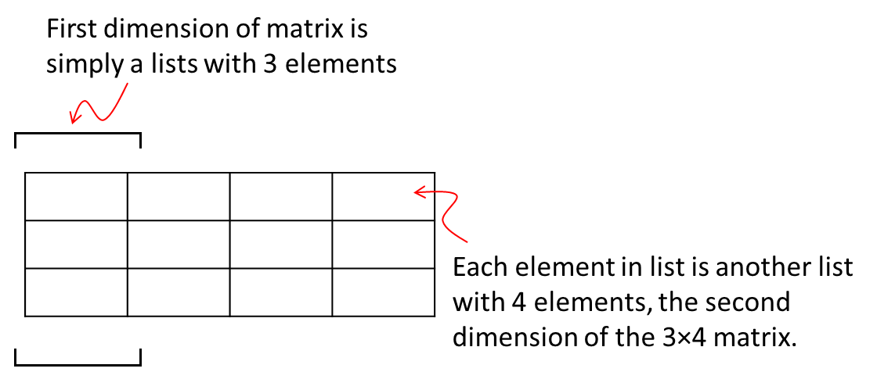
Fig. 12. A two-dimensional matrix can be made with a list, where each list item is another list. Although this is one way to make a matrix, there are more effective ways providing many matrix-specific methods that is part of the Python module Numpy.
number_of_rows = 3
number_of_columns = 4
my_matrix = [0]*number_of_rows
for i in range(0,number_of_rows):
my_matrix[i] = [0]*number_of_columns
print(my_matrix) # [[0, 0, 0, 0], [0, 0, 0, 0], [0, 0, 0, 0]]
Now to illustrate the nested loop:
for x in range(0,number_of_rows):
for y in range(0,number_of_columns):
my_matrix[x][y] = x*y
print(my_matrix) # [[0, 0, 0, 0], [0, 1, 2, 3], [0, 2, 4, 6]]
The inside loop is incremented to give each of the columns, and the outside loop is incremented to give each of the rows. By running through all the columns for each of the rows in turn, we assign a value to each cell in the matrix.

The while-loop
The for-loop executes a fixed number of times until an incrementing “counter” reaches a specified maximum. What if you do not know how many times the loop should be executed? Say you need to evaluate an expression every round of the loop until a condition is not met (becomes False)? This is where the while-loop comes in. The while-loop executes repeatedly (to infinity) until a specified condition is not met.
my_squares = [] # make an 'empty' list object
x=0
my_squares.append(x**2) # x is 0
while(my_squares[x] <= 1000): # is x**2 smaller or equal to 1000?
x+=1 # increment x by 1
my_squares.append(x**2) # append the new x squared to my_squares
print(my_squares[x]) # print value at current index
print("square larger that 1000!") # while loop is done
The condition tested by the while-loop evaluates to either True or False. In the example above the statement my_squares[x] <= 1000 or any condition tested must evaluate to True for the block of code following the colon to execute. The first time when the condition is not met (i.e., x >1000, and the statement evaluates to False) the while-loop is exited, and the line of code following the indented while-block and subsequent lines of code are executed. It is possible to exit a while-loop from within the loop (the indented code block) using a break statement, although this is generally considered bad programming form. Always make sure that the condition tested does eventually return False, otherwise the while-loop will execute as an infinite loop. It is also possible (and acceptable) for the condition being tested to return False the very first time it is evaluated, so that the indented code block following the while-loop is not executed.
The condition tested can also be a compound statement:
my_string="ABCDEFGHIJKLMNOPQRSTUVWXYZ"
string_length = len(my_string)
x=0
while((x < string_length) and (my_string[x] != 'Q')):
print(my_string[x])
x+=1
print('Found it, or not...')
Let’s walk through this one. The purpose of the code is to take one character of my_string in turn, compare it to the query character (‘Q’) until a match is found, and making sure that we have not used all characters in the string. The len() function is a built-in function that returns the number of elements in an iterable such as a list, string, dictionary and so forth. We are slicing the string (my_string[x]) to compare each consecutive character to the query character (‘Q’). It we use an index that points past the end of the string (the position after ‘Z’), Python will generate an error, which would prematurely terminate the program, a condition that we do not want.
The while-loop test whether a condition is True or False. When the condition is a compound statement such as in the example above, Python evaluates the individual conditions from the left to the right. Since we have a compound ‘and’ condition, it means if either the left-hand or the right-hand condition in False, the entire compound condition is False (refer to Table 7). In the code above Python thus first test if we have an index that is past the end of the string. If we have (condition is False), the while loop immediately terminates without evaluating the right-hand condition (it is immaterial since the left-hand condition is False). Thus, we will never try to read a character at an index that is beyond the end of the string, and will therefore never try to evaluate a condition that will generate an error. This is an approach that is worthwhile remembering and using in your own code.
A difficulty of the present code is that when we get to the line following the while block, we do not know whether we have found a match or whether we have exhausted the string. We can test this with a conditional expression.

Conditionals

If, elif, else
The while-loop encountered above will continue executing and looping while a condition evaluates to True. The statement if evaluates a condition once. If it evaluates to True, the indented code following the if statement is executed once. If the condition tested by if evaluates to False, the indented code block is skipped:
my_response = int(input("Enter a number smaller that 5"))
if(my_response < 5):
print("Well done!") # if you followed the instructions...
The condition evaluated by if can also be compound:
my_response = int(input("Enter a number between 0 and 5"))
if((my_response > 0) and (my_response < 5)):
print("Well done!")
You may be interested in what number was entered. To perform multiple evaluations, you can use if-elif constructs. Elif is shorthand for elseif:
my_response = int(input("Enter a number between 0 and 5"))
if(my_response == 1):
print("you entered 1")
elif(my_response == 2):
print("you entered 2")xxxxxxxxxxxxxxxxxxxxxxxxxxx
elif (my_response == 3):
print("you entered 3")
elif (my_response == 4):
print("you entered 4")
The Python interpreter will evaluate the if and the elif statements until a condition is found that evaluates to True. The interpreter will then execute the associated block of code, and jump to the first line of code following the if-elif block. It will skip any additional elif statements once one evaluated to True.
It is also possible to use a catchall else statement in an if block. If the if and all elif statements evaluate to False, the code following the else block is executed. If the if or any elif statement evaluates to True, the else block is skipped.
my_response = int(input("Enter a number between 0 and 5"))
if(my_response == 1):
print("you entered 1")
elif(my_response == 2):
print("you entered 2")
elif (my_response == 3):
print("you entered 3")
elif (my_response == 4):
print("you entered 4")
else:
print("you chose poorly")
We can now return to our last example of the previous section, where we were not quite sure if we had found the query character in our alphabet, or whether we exhausted our list of letters. Using an if-else statement, we can now test to see which option is True:
my_string="ABCDEFGHIJKLMNOPQRSTUVWXYZ"
string_length = len(my_string)
x=0
my_character = str(input("Enter one character"))
while((x < string_length) and (my_string[x] != my_character)):
x+=1
if(x != string_length):
print("found entry at index",x)
else:
print("the query entry was not found")

Exercise Day 3
- The for x in range(1,10): statement will generate the following sequence of values for x:
  - 1,2,3,4,5,6,7,8,9
  - 1,2,3,4,5,6,7,8,9,10
  - 1,1,1,1,1,1,1,1,1,1
  - 9,8,7,6,5,4,3,2,1
  - 10,9,8,7,6,5,4,3,2,1
- The statement range(1,5,2) stores the following in memory:
  - The sequence object returned by the range built-in function
  - 1,2,3,4,5
  - 1,3
  - 3,5
  - 1,3,5
- The statement for x in range(5,1,-1): will generate the following sequence of values for x:
  - 5,4,3,2
  - 5,4,3,2,1
  - 1,2,3,4,5
  - 1,2,3,4
  - -1,-2,-3,-4,-5
- In the statement for x in object:, object can be replaced by
  - Any iterable object
  - Only with a range build-in function
  - Only with a sequence of values
  - Only with a list of values
  - Any non-iterable object
- A for-loop is typically used to
  - Repeat a section of code a specified number of times
  - Repeat a section of code until a condition is True
  - Repeat a section of code an undefined number of times until a condition is met
  - Format code into neat blocks
  - Test the Boolean value of an expression
- In a nested for-loop, one can
  - Generate each value of x for each individual value of y
  - Increment variables x and y independently
  - Generate values for x defined by the value of y
  - Generate values for x and y independently
  - Use only a single variable
- The statement my_sequence = [1]*3 will generate the following for my_sequence:
  - [1,1,1]
  - [1],[1],[1]
  - [111]
  - [3,3,3]
  - [3]
- Three nested for-loops can typically be used to initialize a
  - Three-dimensional matrix
  - A list with three data members
  - Three independent lists
  - A two-dimensional matrix
  - An n-dimensional matrix
- A while loop typically allows repeat execution of a block of code until
  - A condition is met
  - A counter matches an upper limit
  - The iterated object is exhausted
  - The while expression is True
  - The block of code is exhausted
- The following code
i=0
while(i<10 and i%2==0):
print(i)
i += 1
  - Will print the integer 0
  - Will print out even positive integers smaller than 10
  - Will print out uneven positive integers smaller than 10
  - Will execute as an infinite loop
  - Will not print any output
- A while loop will terminate
  - The first time the while conditional expression evaluates to False
  - The last time the while conditional expression evaluates to False
  - When the iterator is exhausted
  - The maximum of the range sequence is encountered
  - When the block is exited with a break statement
- When a while loop terminates
  - The line of code following the indented while block is executed
  - The last line of the indented while block is executed
  - The last line that was executed before the while block initialized, is executed
  - The program terminates
  - User input is required
- In the compound while statement while (condition 1 and condition 2), the while code block will execute if:
  - Condition 1 is True and condition 2 is True
  - Condition 1 is False and condition 2 is True
  - Condition 1 is True and condition 2 is False
  - Condition 1 is False and condition 2 is False
  - Irrespective of the values returned by conditions 1 and 2
- In the compound while statement while (condition 1 and condition 2), a decision on whether the while block must execute is made:
  - Directly after evaluating condition 1, if it evaluates to False
  - Directly after evaluating condition 1, if it evaluates to True
  - After first evaluating condition 2
  - After both condition 1 and 2 are evaluated
  - After evaluating the conditions from the right to the left
- An if (condition) statement will
  - Execute the code block once if the condition evaluates to True
  - Execute the code block once if the condition evaluates to False
  - Execute the code block repeatedly, incrementing a counter
  - Execute the code block repeatedly until a set maximum is reached
  - Immediately execute the line of code following the if code block
- An if (condition)… else… statement will
  - Not execute the code block following the else statement, if condition evaluates to True
  - Will execute the code block following the else statement, if condition evaluates to True
  - Will execute the code block following the else statement, regardless of the evaluated value of condition
  - Will execute both code block following if and else, if condition evaluates to True
  - Will execute both code block following if and else, if condition evaluates to False
- In an if (condition 1) … elif (condition 2) … elif (condition 3) … block,
  - Only code block following the first condition that evaluates to True is executed
  - The code block following each if or elif statement that evaluates to True is executed
  - If condition 1 evaluates to True, only elif conditions that evaluate to True are executed
  - If condition 1 evaluates to False, only elif conditions that evaluate to True are executed
  - Each elif statement can have a local else clause
- In an if (condition 1) … elif (condition 2) … else block, the code following the else clause will be executed
  - If neither condition 1 or condition 2 evaluates to True
  - Will be executed if either condition 1 or condition2 evaluates to False
  - Will be executed if condition 1 evaluates to True, but condition 2 evaluates to False
  - Will be executed regardless of the value of condition 1 and condition 2
  - Will be executed is any elif statement is False
- An important difference between a while and if statement is
  - A while block will repeat until a condition is not met
  - A while block will repeat until a condition is met
  - An if block will be executed at least once
  - A while block will be executed at least once
  - A counter can be incremented in a repetitive if block
- An important difference between a for and if statement is
  - A for statement is intended to repeat a block of code
  - A for statement is intended to evaluate a condition
  - An if statement is intended to repeat a block of code
  - For and if statements can be used for the same purpose
  - An if statement can iterate over a sequence
- The “:” (colon) and indented lines in a while block
  - Indicates the scope of the while statement to the interpreter
  - Is solely to improve readability of the text
  - Is not required
  - Can consist of a variable number of spaces
  - The “:” is not required
- A while statement that always evaluates to True
  - Generates an infinite loop
  - Generates an exception
  - Is the same as an if statement
  - Is a code block that executes at least once
  - Will terminate after the counter exceeds a set maximum value
- The sequence 20,17,14,11 will be generated by the following statement
  - for i in range(20,10,-3)
  - for i in range(10,20,-3
  - for i in range(20,11,-3)
  - for i in range(10,19,-3)
  - for i in range(11,19,3)
- The correct order for the statements within an if block is
  - If (condition 1) … elif (condition 2) … else …
  - If (condition 1) … else … elif (condition 2) …
  - Elif (condition 2) … if (condition 1) … else …
  - Elif (condition 2) … else … if (condition 1) …
  - Else … elif (condition 2) … if (condition 1) …
- In the compound while statement while (condition 1 or condition 2), a decision on whether the while block must execute is made:
  - Directly after evaluating condition 1, if it evaluates to True
  - Directly after evaluating condition 1, if it evaluates to False
  - After first evaluating condition 2
  - After both condition 1 and 2 are evaluated
  - After evaluating the conditions from the right to the left
- Given my_list = [‘rock’,’paper’,’scissors’], the statement for a, b in enumerate(my_list) will return the following values during the iteration:
  - 0 rock, 1 paper, 2 scissors
  - (0,rock), (1,paper), (2,scissors)
  - 0,1,2
  - rock, paper, scissors
  - [‘0 rock’,’1 paper’,’2 scissors’]

Functions

Simple Functions
We have encountered built-in functions like print(), range() and len() previously. If we have specific blocks of code that is useful and that we use often, it is very convenient to define these as functions that we can call, similarly to using print() and other built-in functions.
It is very easy to define a function for a body of code:
def function_name(optional parameters):
Indented code to do what you want to do
return(parameter)
The function name is preceded by the def statement to indicate to the interpreter that a function definition follows. The function can receive parameters, listed in the round brackets, followed by the colon, to indicate the start of the function block. The function code block is indented. The function need not return a value. If it does, it uses the return statement, followed by the parameters that must be returned in round brackets.
Let us make a simple function that calculates the square of a number:
def square(x):
x_squared = x**2
return(x_squared)
number = 3
my_square = square(number)
print(my_square) # 9
Note
The function square() is defined before it is used. This is essential, since the interpreter must know what the function does for the subsequent code to use it.
The function square is defined to receive a single value in the variable x. The interpreter does not know what the data type of x is until a value is passed to the function. The variable number is set to 3, and is passed to the function square. Note that the value of number is copied to the function parameter x. Thus x is 3 after the function has been called. The square of x is calculated in the function and assigned to the variable x_squared. The function returns x_squared. The returned value of x_squared is assigned to the variable my_square in the line of code that called the function, which is then printed.
As you saw for built-in functions earlier, a function can receive more than one parameter:
def power(b,e):
return(b**e)
base = int(input("enter a base number"))
exponent = int(input("enter an exponent number"))
print(power(base,exponent))
If a specific parameter often takes the same value, you can define the value as a default, and call the function without the parameter. In the example below, when the power function is called without the exponent parameter, the default value of 2 is used as exponent.
Note
Once you have defined a default value, all subsequent parameters must also have default values, otherwise the interpreter cannot work out to which parameters you are passing values.
def power(b,e=2):
return(b**e)
base = int(input("enter a base number"))
exponent = int(input("enter an exponent number"))
print(power(base,exponent)) # 8
print(power(base)) # 4
A function can return more than one value. You can use a tuple to accomplish this.
def rectangleproperties(l,s):
circumference = 2*l+2*s
area = l*s
return((circumference,area))
long = int(input("long side")) # 3
short = int(input("short side")) # 2
print(rectangleproperties(long,short)) # (10, 6)

Variable Scope
Now that we have met functions, it is an appropriate time to introduce variable scope. Essentially, in Python (and other programming languages), the variable scope is the neighbourhood where the variable name is known, also described as namespace. Not knowing the variable everywhere is very important: you may import a module that contains a variable name identical to one in your code. Which variable should the interpreter use? Variable scope makes sure that the interpreter can discriminate between different variables with the same name. For instance:
def My_Function():
x = 0
print(x) # 0
x = 1
My_Function()
print(x) # 1
Inside the function x is 0; outside the function x is 1. The moment x is assigned in the function, it becomes a local variable, known only in the function. When x is not assigned inside the function, it is global:
def My_Function():
print(x) # 1
x = 1
My_Function()
print(x) # 1

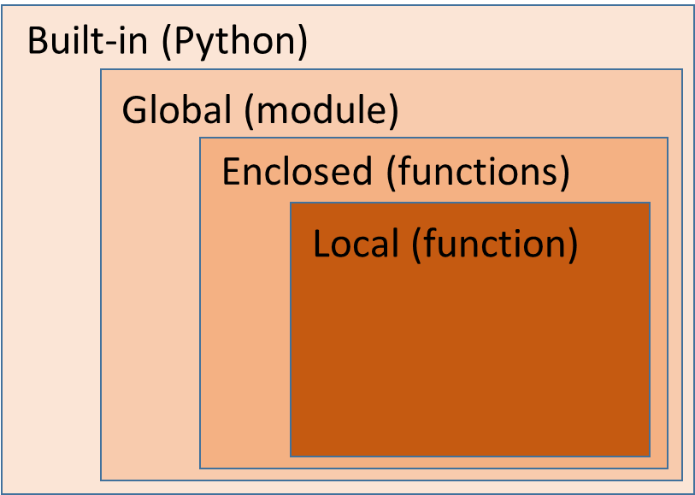
Fig 13. Variable scope. The level at which a variable is assigned, determines the scope of the variable as local, enclosed, global, or built-in.
When trying to find the value of a variable, the interpreter will start looking at the level matching that where the variable was encountered, and will progressively step to the broader scopes (outer rectangles in Fig. 13) until an assignment is found. If no assignment is found, the interpreter will generate an error.
NameError: name 'x' is not defined
def My_Function():
x=0
print(x) # 0
def My_Inner_Function():
print(x) # 0
My_Inner_Function()
x = 1
My_Function()
print(x) # 1
When printing x in My_Inner_Function(), the interpreter looks for an assignment to x in My_Inner_Function(), does not find one, and then proceeds to look for an assignment in the enclosing function, My_Function(), where an assignment was found, and used. The assignment to the global function (=1) is used at global scope. Note that the term global is ambiguous. In Python, global scope really is the scope of the module (or file).
When the same variable name is used for a parameter passed to a function, the passed variable becomes a local variable because it is assigned after the def keyword.
def My_Function(x):
print(x) # 1
x=0 # x is a local variable and re-assignment has
# no effect of the global x (=1)
x = 1
My_Function(x)
print(x) # 1
When a function returns a parameter, the global variable is only re-assigned if the value returned by the function is assigned to it:
def My_Function(x):
print(x) # 1
x=0
return(x)
x = 1
x = My_Function(x) # The global variable x is re-assigned (=0)
print(x) # 0
When you want to assign a value to a global variable inside a function, you can declare the variable global, in which case the assignment is to the global version:
def My_Function():
global x
x=0
print(x) # 0
x = 1
My_Function()
print(x) # 0; x was re-assigned in My_Function()
Make sure you are comfortable with the concept of variable scope. It can be a nightmare trying to understand why variables with the same name have different values in different namespaces if you do not keep track of scope.

Recursive functions
A recursive function is a function that calls itself. This may sound like a bad idea, because an infinite loop sounds certain. You have to clearly test for a terminating condition to end the recursion. When will you use a recursive function? When you need to repeatedly execute the same bit of code until an end condition is met. Although you can repeatedly call the function from your main body of code, it is tidier to have the function call itself until the terminating condition is met.
def power(number, counter):
if(counter > 0):
value = power(number, counter-1) * number
else:
value = 1
return(value)
base = 2
exponent = 4
print(power(base,exponent)) # 16
Note that the function call within the line of code is like any other operand: the value that is returned by the function is substituted in the place of the function. So in the line of code:
value = power(number, counter-1) * number
the value of “power(number, counter-1)” is substituted in its place. Carefully look at the code of the recursive function. If the counter > 0 the function calls itself with the counter decremented by 1. It carries on calling itself with a decremented counter until the condition counter > 0 is False, i.e., the value of the passed counter is 0. If that happens the function returns the value 1. Where does it return this value? The line of code that called it, which is itself. The easiest way to visualize this is to write the line that causes recursion, and substitute all its parameters with the correct values.
1 # counter = 0
2 = 1 * 2 # counter = 1
4 = 2 * 2 # counter = 2
8 = 4 * 2 # counter = 3
16 = 8 * 2 # counter = 4

The recursion thus “unwinds” itself, multiplying the result of the previous calculation with 2, passing the result to the function one level up, shown above by the next line down. This is repeated until we get to the original function that started the call with number = 2 and exponent = 4. This is the originating level. The answer is 16. There are of course much easier ways to calculate powers, but the operation lends itself well to illustrating the concept of recursion. Let’s do another example: simple multiplication.
def power (number, counter):
if(counter > 0):
value = power(number, counter-1) + number
else:
value = 0
return(value)
number_1 = 2
number_2 = 4
print(power(number_1,number_2)) # 8
Again, look at the values of the recursive line
value = power(number, counter-1) + number

0 # counter = 0
2 = 0 + 2 # counter = 1
4 = 2 + 2 # counter = 2
6 = 4 + 2 # counter = 3
8 = 6 + 2 # counter = 4
The recursion digs until the terminating condition is met (counter == 0). It then passes the value calculated at this level to the function one level up, and continues passing the calculated result up until the level of the originating function is reached.

Classes

Classes
Up to now we have only seen short code snippets. Real programs in bioinformatics are much bigger, and can run into thousands of lines of code. Imagine you want to read the individual chromosome sequences from a fastA file, calculate the AT% of each chromosome, and print it. Not a particularly complex program, but one that will nonetheless take a good number of lines of code. That is, if you program in a linear fashion, starting with the code to read the sequences, storing the sequences in memory, retrieving each sequence in turn, calculating the AT%, and printing the result. Such a type of linear program is old fashioned, and very difficult to maintain, because the code will often jump to positions forwards of backward in the code. The BASIC programming language with its GOTO statement followed by a code line number is an example.
Nowadays programs are object-oriented. Object orientation is a serious topic in computer science, and we must busy ourselves only with what is important. We use object-orientation to make it easier for ourselves to write the code, to make the code easier to understand, and by having the opportunity to re-use bits of code in different programs.
The basic idea behind object-orientation is to group together functions that are relevant to a given data type or to a specific type of calculation, in an object. Remember the functions that we could apply to strings (see Table 6)? Functions such as capitalize(), len(), find() and so forth. These functions were all invoked as my_string.capitalize(). Here my_string is, in fact, an object and the functions in Table 6 all belong to the string object, and can be applied to the object data. However, object functions need not only be applicable to object data. You can code the functions so that they are applicable to any data. For instance, you may want a Statistics object, and the Statistics object has functions such as Average() and Median() and so on. So whenever you need to do a statistical calculation, you make your Statistics object, and use its functions:
my_statistics.median(my_list)
In this way you keep all the related function logically together in one group. Why am I using my_statistics above, and not Statistics? Because we are using an instantiation (or object), called my_statistics of the class Statistics. A class is essentially the description of the all data types and functions that are available to the object. They are collectively referred to as attributes of the object. To continue with pure Python terminology, functions are called methods when they are defined as part of a class. In other words, the class described all the methods and data members that it contains. You never use a class directly, You instantiate a class as follows:
my_instantiation_of_class = my_class()
The my_instantiation_of_class is an instantiation of the class, or an object. It is the same thing. So you define a class, instantiate it, and then use the class instantiation object. Let’s look as specific examples:
class My_class:
def Method_1(self):
print("This is method 1")
def Method_2(self):
print("This is method 2")
my_class = My_class()
my_class.Method_1() # This is method 1
my_class.Method_2() # This is method 2
You instantiate the class My_class with the statement:
My_class()
The instantiated class or object is then assigned to the variable my_class. You can use the my_class variable (or object) to call the class methods, Method_1() or Method_2().
You will have noticed that the methods Method_1() and Method_2() were defined with the parameter self being passed, yet these methods were called from the code with no parameter. What is the story here? The self parameter can be thought of as a label that uniquely identifies the object, and is equivalent to the this pointer in C++. You can make numerous objects of My_class by repeatedly calling My_class(), and each would have its own unique self identifier. When the interpreter access the object methods, it uses the object identifier self “internally” – so you do not have to explicitly supply a value for self. Let’s dig some more.
Whenever a class is instantiated, a call to __init__(self) is made. This is equivalent to the C++ constructor. You can explicitly define this function and initialize some object parameters that you wish to initialize. Similarly, there is a destructor __del__(self) that is called just before the object goes out of scope (is destroyed).
In the C++ programming language you have data encapsulation where classes have public, protected and private attributes, making specific member functions and data members only accessible to objects or to member functions themselves. Python has no data encapsulation. For instance, look at the following code:
class Dogs:
number_of_legs = 4
def __init__(self, name):
self.dog_name=name
def __del__(self):
pass
def Show_name(self):
print(self.dog_name)
my_dog = Dogs('Hoppertie')
my_dog.Show_name() # Hoppertie
print(my_dog.dog_name) # Hoppertie
print(my_dog.number_of_legs) # 4
print(Dogs.number_of_legs) # 4
We can inspect the data member dog_name using the object method Show_name(), or we can directly access it, using the object my_dog as reference as in my_dog.dog_name. Class-wide attributes such as number_of_legs can be accessed via a class reference (Dogs.number_of_legs) or the object (my_dog.number_of_legs), although the object reference is a local, object copy, and can independently be manipulated. Be careful, if you change a class attribute value via the class reference it is changed for all instances of that class. If you change it via the object reference, it is only changed for that object:
class Dogs:
number_of_legs = 4
def __init__(self, name):
self.dog_name=name
def __del__(self):
pass
my_dog = Dogs('Hoppertie')
my_dog2 = Dogs('Toppeltop')
print(my_dog.number_of_legs) # 4
Dogs.number_of_legs = 6
my_dog.number_of_legs = 5
print(my_dog.number_of_legs) # 5
print(my_dog2.number_of_legs) # 6

Inheritance
You can extend a class by inheriting it. The base class from which you inherit must be in the same scope as the derived class.
class BaseClass:
def __init__(self):
self.my_data = 1
def ShowData(self):
return(self.my_data)
class DerivedClass(BaseClass):
def __init__(self):
self.my_data = 2
def ShowData(self):
return(self.my_data)
my_base_object = BaseClass()
my_derived_object = DerivedClass()
print(my_base_object.ShowData()) # 1
print(my_derived_object.ShowData()) # 2
Note that identically named object methods and data members override any defined in the base class. If a method is called that does not exist in the derived class, the base class is searched for the specified method. It should therefore be clear that the intention of base class, say ‘Cars’, is to define primitive functions that will be relevant to many different types of objects related to ‘Cars’. In derived classes additional methods and data members can be defined that is of value in a more narrowly specified object such as ‘Electric’ or ‘High_Performance’ and so forth. Object Oriented Programming (OOP) is a field by itself. If you would like to learn more, view presentations on YouTube or start with books such as Head First Object-Oriented Analysis and Design by McLaughlin, Pollice and West.
Classes is an excellent tool to develop libraries of functions for yourself from which you can inherit, refine and use in serious bioinformatics applications for years to come.

Containers and Iterations
We have seen many examples of iteration: in for-loops, list comprehensions and generator functions. Iteration is simply where repeated request to an object gives consecutive data members from a collection until the collection is exhausted. A class, and therefore the instantiated object, can be iterated if two specific methods are implemented in the class:
__iter__()
__next__()
Classes that allow iteration over data members are known as containers. We have previously met the double underscore __init__() function, which is called when the class is instantiated, and allows initiation of any required data members and other housekeeping tasks that must be performed before the object is complete and usable. The double underscore methods are predefined, and behave in a default manner unless overridden by the programmer. If you derive a class from an existing class, all methods defined in the parental class is inherited. However, you can define the identical functions in your derived class, and implement different behavior. If the method is called in your derived, instantiated class, your method will be called, not the method with the same name in the parental class. Thus, you can override the __iter__() and __next__() methods.
The data types lists, strings, dictionaries, tuples etc. are all iterable classes, implementing __iter__() and __next__(). When Python iterates over an object, it first calls __iter__(). This function should return the reference self, which is interpreted as a reference to an iterator. Python then uses the self reference to call the __next__() method repeatedly, which should return consecutive members of a sequence with each call until the sequence is depleted. The following call to __next__() must raise the exception StopIterator. Exceptions are discussed later. For our discussion here, it is sufficient to know that it is a system whereby a program raises a notification when an unusual situation, not generally handled by the program, arises. However, exceptions can be caught and handled, where a program responds appropriately, and normal program execution continues.
Note
Once Python starts calling the __next__() method, it cannot be “reset” and the sequence restarted: the iteration must either be exited (poor style) or completed.
The following class implements iteration over its one data member:
class My_Class:
# pass a list to the object with initialization
def __init__(self, list_data):
self.list_data = list_data
self.index=len(self.list_data)
# When Python calls for iteration, set counter to 0
def __iter__(self):
self.counter = 0
return(self)
# Check bounds, increment counter, and return list item at previous counter
def __next__(self):
if (self.counter < self.index):
self.counter += 1
else:
raise StopIteration
return (self.list_data[self.counter-1])
my_list = [0,1,2,3,4,5,6,7,8,9]
my_object = My_Class(my_list)
for i in my_object:
print(i,end=" ") # 0 1 2 3 4 5 6 7 8 9
Note
The __getitem__() method behaves like __next__(), but is deprecated, and should not be used.

Assignment Day 4

Write a program to read the names and sequences from a fastA file, and to calculate the AT% of each sequence

Download the file “demo_fasta_file_2018.fsa” from SUNlearn, and save it on your computer in the same directory that will contain your Python program file. For example, in “C:\Users\hpatterton\PycharmProjects\helloworld\source\demo_fasta_file_2018.fsa”. The exact path will be similar but different on your computer.
Write a program that returns:
- the number of sequences in the downloaded fastA file, as well as
- the name of each sequence,
- the sequence itself, and
- the AT% of each sequence.
Write the program by defining the following 3 functions that are called in the main code block, below:
Insert your own code to accomplish the intended purpose of each function:
#<<<<<<<<<<<<<<<<<<< COPY CODE BELOW FROM HERE>>>>>>>>>>>>>>>>>>>>
def Number_Of_Sequences(filepath):
#=====================================================================
# Return the number of sequences in the downloaded
# “demo_fasta_file_2018.fsa” file as an integer in the variable
# ‘number_of_sequences’
#=====================================================================
#*********************************************************************
# YOUR CODE GOES HERE
#*********************************************************************
return(number_of_sequences)
def Read_FastA_Names_And_Sequences(filepath):
#=====================================================================
# Return a tuple composed of two lists: ‘sequence_names’ and ‘sequences’
# that contain the sequence_names and sequences read from the downloaded
# fastA file. The sequence_names list must contain string elements
# corresponding to each name, and the sequences list must contain string
# elements corresponding to each sequence. The string elements may not
# contain spaces, newline or ‘>’ characters. #=====================================================================
#*********************************************************************
# YOUR CODE GOES HERE
#*********************************************************************
return((sequence_names,sequences))
def AT_Percentage(sequences):
#=====================================================================
# Return a list in AT_percentage that contain the AT% of each of the
# sequences passed in the list ‘sequences’(read from the downloaded
# fastA file) as a float
#=====================================================================
#*********************************************************************
# YOUR CODE GOES HERE
#*********************************************************************
return(AT_percentage)
#=====================================================================
# MAIN CODE BLOCK
# This block of code will execute correctly if your functions return
# the data according to the instructions above
# DO NOT MODIFY ANY OF THE CODE BELOW
#=====================================================================
filepath=str("demo_fasta_file_2018.fsa")
number_of_sequences = Number_Of_Sequences(filepath)
print("Number of sequences =",number_of_sequences)
sequence_names,sequences = Read_FastA_Names_And_Sequences(filepath)
AT_Percentage = AT_Percentage(sequences)
for i in range(0,number_of_sequences):
print(sequence_names[i],'\n',sequences[i],'\n',AT_Percentage[i])
print('done...')
#<<<<<<<<<<<<<<<<<<< COPY CODE ABOVE TO HERE>>>>>>>>>>>>>>>>>>>>

The program should produce output like the following:
Number of sequences = 3
chromosome_1
GATCGATCGAGATCGATCGAGATCGATCGAGATCGATCGAGATCGATCGAGATCGATCGAGATCGATCGAGATCGATCGA
50.0
chromosome_2
GATCGATCGAGATCGATCGAGATCGATCGAGATCGATCGAGATCGATCGAGATCGATCGAGATCGATCGAGATCGATCGAGATCGATCGAGATCGATCGAGATCGATCGAGATCGATCGAGATCGATCGAGATCGATCGAGATC
50.0
chromosome_3
TTTTGGAAAATTTTGGAAAATTTTGGAAAATTTTGGAAAATTTTGGAAAATTTTGGAAAATTTTGGAAAATTTT
80.0
done…
Note: your program will be marked by executing it, using a different fastA file to ensure that your code functions properly.
To submit your program, upload your completed, functioning text file to SUNlearn using your student number and a “.py” extension as file name, eg. “2010031648.py”. Your filename must not contain any other characters, spaces or symbols. If your file name format is incorrect, your assignment will not be marked. Make sure your file is functional and can execute as a Python script. If it does not execute correctly, it will not be marked. Do not e-mail your program or submit it as a hard copy. It will not be marked. Programs that are submitted to SUNlearn after the submission deadline will not be marked.
Please be aware of the policies and rules of Stellenbosch University regarding plagiarism when submitting work as your own.
MARKS (25)
Number_Of_Sequences(filepath) returns the correct number of sequences (5)
Read_FastA_Names_And_Sequences(filepath) returns a tuple composed of two lists (5)
Read_FastA_Names_And_Sequences(filepath) returns the correct sequence names in the list 'sequence_names' (5)
Read_FastA_Names_And_Sequences(filepath) returns the correct sequences in the list 'sequences' (5)
AT_Percentage(sequences) returns the correct AT% for each sequence as a list of floats in 'AT_percentage' (5)

Modules

Importing modules
It was previously mentioned that you can write your own classes with methods that are useful for your own work, and then re-use these classes in programs that you subsequently write. If, for instance, you have a class called My_Class saved in a file called My_Class_File.py, you can simply import My_Class_File.py as
import My_Class_File
this loaded file is called a module. The paths searched for the specified module is in the following order:
- The directory of the program file that specifies the import
- PYTHONPATH (a list of directory names)
- The installation-dependent default directory
Note that you must omit the ‘.py’ file extension from the name specified for import. You have access to the class or classes specified in My_Class_File by referencing the imported module:
my_object = My_Class_File.My_Class()
my_other_object = My_Class_File.My_Other_Class()
Alternatively, you can import a specific class as
from My_Class_File import My_Class
and use it without reference as
my_object = My_Class()
Apart from classes and functions that you may define and reuse in programs, there are many third-party modules that are extremely useful in Bioinformatics:

Biopython (biopython.org)
Biopython includes classes and resources for sequence reading, writing and manipulation, sequence alignment, BLAST, downloading data directly from NCBI and Expasy servers, manipulating and analyzing PDB format data, population genetics and phylogenetic analyses, motif analyses, cluster analyses and supervised learning methods.
Visit the Biopython website and scan the documentation. Many run-of-the-mill tasks in bioinformatics have been addressed and solutions are available in Biopython. Do not re-invent the wheel.

Numpy (www.numpy.org)
Numpy support may fundamental features of scientific programming using Python, including n-dimensional arrays, incorporating C/C++ and FORTRAN in Python code, and many useful linear algebra routines, Fourier transforms, and random number functions.

Scipy (www.scipy.org)
Is a core to Numpy and includes many numerical, integration, signal processing, fast Fourier transforms, linear algebra, and graphic processing methods.

Numpy
We will not be doing a major overview of Numpy in this course. There are many excellent online tutorials available that covers the module in depth. However, one important feature in Numpy that we will cover because of its ubiquitous application in bioinformatics, is arrays. Although the standard Python library does offer a functional array data type, its properties and methods are rather limited, and users are encouraged to start with using the ndarray (for n-dimensional array) class from Numpy.
An array is a n-dimensional list. In Python arrays, a dimension is referred to as an axis, and the number of axes, as the rank. Two-dimensional arrays or matrices are often used, and is composed of rows and columns. Each cell in a matrix is addressable by the index of its row and column, both indexed from 0.
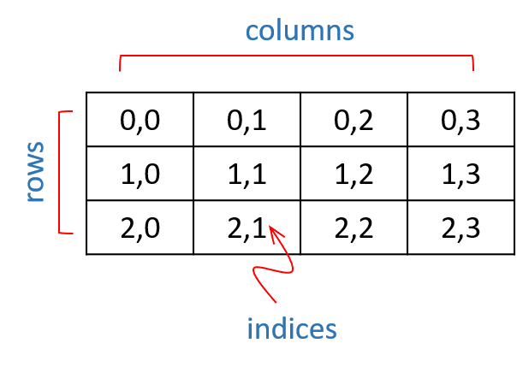
Fig. 14. A 2-dimensional array
To use ndarray (also known by its alias ‘array’) from Numpy, you must import the numpy module:
import numpy
my_array = numpy.array([0,1,2,3]) # [0 1 2 3]
You can also define an alias for the module, allowing a shorthand reference:
import numpy as np
my_array = np.array([0,1,2,3]) # [0 1 2 3]

Creating an array
An array is created by passing a single list to the class with initialization. If you want a n-dimensional array, you can pass a list with the appropriate number of list items:
my_array = np.array([[0,1,2],[3,4,5]]) # 2-dimensional array
Alternatively, you can pass a 1-dimensional list, and reshape the array after instantiation. The number of elements in the reshaped array must match that in the original list.
my_array = np.array([0,1,2,3,4,5])
my_array=my_array.reshape(2,3)
[[0 1 2]
[3 4 5]]

my_array=my_array.reshape(2,4) # WRONG, 8 items != 6 items
If you do not know the contents of the array at instantiation, you can fill it with 0s, 1s or random floating-point number, defining the size with a tuple:
my_array=np.zeros((2,3))
[[ 0. 0. 0.]
[ 0. 0. 0.]]
The default data type is float64.
You can define the data type with dtype:
my_array = np.zeros((4, 4),dtype=int)
[[0 0 0 0]
[0 0 0 0]
[0 0 0 0]
[0 0 0 0]]

Elementary mathematical operations
Mathematical operations on arrays are usually elementwise, i.e. cell A1 operator cell B1 = result. Given:
A = np.array([[0,1],[2,3]])
B = np.array([[1,1],[2,2]])

A+B =
[[1 2]
[4 5]]
A-B =
[[-1 0]
[ 0 1]]
A*B =
[[0 1]
[4 6]]
And A/B =
[[ 0. 1. ]
[ 1. 1.5]]

The arrays must be of identical size and shape to apply elementary mathematical operands.

Dot product
An extremely widely used matrix operation is the dot product A·B:
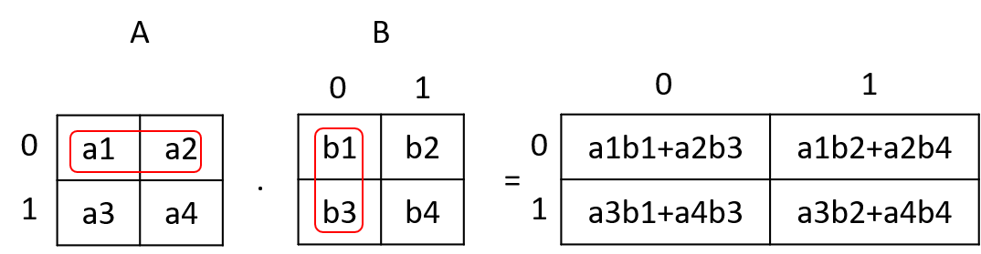
Fig. 15. In a dot product, row 0 is applied to column 0, multiplying the parameters is each overlaid cell, and adding the products, and so on, for each row in A and each column in B. The number of columns in array A must match the number of rows in array B. It is therefore possible to calculate the dot product of 2×3 and 3×4 matrices, giving a product matrix of size 2×4. In the general case the size is P×M·M×Q producing a P×Q array.
Given arrays A and B, one can compute the dot product using three nested for-loops in a rather cumbersome way. Note the use of arange(), a ndarray class method similar to the built-in function range(), where arange() returns an object with data type numpy.ndarray with a 1-dimensional list of integers in the specified range:
import numpy as np
number_of_rows_A = 2
number_of_columns_A = 2
number_of_rows_B = 2
number_of_columns_B = 3
A = np.arange(number_of_rows_A*number_of_columns_A).reshape(number_of_rows_A,number_of_columns_A)
B = np.arange(number_of_rows_B*number_of_columns_B).reshape(number_of_rows_B,number_of_columns_B)
C = np.zeros((number_of_rows_A,number_of_columns_B))
for row in range(0,number_of_rows_A):
for column in range(0,number_of_columns_B):
for inner_column in range(0,number_of_columns_A):
C[row,column] += A[row,inner_column]*B[inner_column,column]
A = [[0 1],[2 3]]
B =[[0 1 2],[3 4 5]]
C: [[3. 4. 5.],[9. 14. 19.]]

Alternatively, and much easier, the three nested for-loops can be replaced with:
C=A.dot(B) # [[3. 4. 5.],[9. 14. 19.]]
Note that the dot product function is a method of the ndarray class, and the array object must thus be referenced.

Sum, min and max
You can also sum or calculate the minimum and maximum or an array:
A = np.arange(6).reshape(2,3)
print(A.sum()) # 15
print(A.min()) # 0
print(A.max()) # 5
The axis (dimension) used for sum, min or max can be specified:
print(A) # [[0 1 2],[3 4 5]]
print(A.sum(axis=0)) # [3 5 7]
print(A.min(axis=1)) # [0 3]
print(A.max(axis=1)) # [2 5]

Indexing and slicing
Individual cells in an array can be accessed with a [row,column] index (or [dimension 1, dimension 2, dimension 3, …] in the case of an n-dimensional array):
A = np.arange(6).reshape(2,3)
print(A[1,2]) # 5
Arrays can also be sliced:
A = np.arange(6).reshape(2,3)
B = A[0,:] # [0,1,2] row 0, all columns
C = A[-1,:] # [3 4 5] last row, all columns
D = A[0:2,0]) # [0 3] rows 0 and 1, column 0

Iteration
Arrays can be iterated over. The 0 axis is used:
A = np.arange(6).reshape(2,3)
for item in A:
print(item)
[0 1 2]
[3 4 5]
You can also access each item in an array be “flattening” it before iteration:
for item in A.flat:
print(item)
0
1
2
3
4
5

Identity and transposed matrices
An identity matrix (I) is composed of all zeroes except for the diagonal of ones, and can only be square (N×N). It is very useful in linear algebra because it has the property that
N·I = I·N = N
and in calculating the inverse, A⁻¹, of a matrix A because
A·A⁻¹ = A⁻¹·A= I
An identify matrix can be created by specifying the size of one axis:
I = np.eye((3),k=0,dtype=int) # default k=0 and dtype=int
[[1 0 0]
[0 1 0]
[0 0 1]]
The offset of the diagonal can be set with k to produce a matrix of 0s and 1s that is not the identity matrix:
I = np.eye((3),k=1,dtype=int)
[[0 1 0]
[0 0 1]
[0 0 0]]
Matrices can be transposed (switching the rows and columns, maintaining their order). Transposed matrices have wide application in linear algebra (and, therefore, bioinformatics, gaming graphics, signal and image processing, etc.):
A = np.array([0,1,2,3]).reshape(2,2)
A_t = A.transpose()
print(A) # [[0 1] [2 3]]
print(A_t) # [[0 2] [1 3]]
A matrix need not be square to be transposable:
A = np.array([0,1,2,3,4,5]).reshape(2,3)
A_t = A.transpose()
print(A) # [[0 1 2] [3 4 5]]
print(A_t) # [[0 3] [1 4] [2 5]]

Exceptions
Properly coded programs generally executes successfully under most conditions, terminating with exit code 0. However, even properly coded programs may encounter unexpected conditions. For instance, the file that the program tries to read may be in an unexpected format, or the denominator of a fraction has been rounded to zero, or the input from a user exceeds a prescribed range. It is impossible when coding a program to think of and preempt every possible problem that a program may encounter. This is why Python and other modern computer languages allow exceptions.
When a condition arises that cannot be handled by the code that is being executed, an exception is raised or thrown.
print(x/0) # ZeroDivisionError: division by zero
Typically, the interpreter will report the exception, and then terminate the program, reporting an exit code of 1. However, it is possible to catch an exception, handle it correctly, and then either exit the program gracefully, or continue executing the program. An exception is caught in a try…except block. As a simple example, this code generates an exception when the calculation of log10 of 0 is attempted:
import math
my_list = [1000,100,10,0]
for x in my_list:
print(math.log10(int(x))) # 3.0 2.0 1.0 ValueError: math domain error
We can catch the exception with a try block:
for x in my_list:
try:
print(math.log10(int(x)))
except ValueError:
print('not defined')
The statement in the try block is executed. If no exception is raised, the interpreter continues with the line after print('not defined'). If an exception is raised, an except block that matches the error is searched for. If one is found (an attempt to calculate log10 of 0 raises a ValueError exception), the block of code in the exception block is executed.
3.0
2.0
1.0
not defined
The program then continues with the first line following the try…except block. It is possible having multiple except statements. Note that the first matching except block is executed.
try:
print(math.log10(int(x)))
except ZeroDivisionError:
print('division by 0 is undefined')
except ValueError:
print('not defined')
except NameError:
print('not a number')
3.0
2.0
1.0
not defined

Exception values can also be tested as a tuple:
try:
print(math.log10(int(x)))
except (ZeroDivisionError,ValueError,NameError):
print('one of 3 possible errors')

a catch-all exception does not define a error value:
try:
print(1000/x)
print(math.log10(int(x)))
except:
print('this can be any exception...')

Note: simply catching and ignoring all exceptions (as we do above) is not a good idea, because the program may continue executing with a value assigned to a variable that will cause trouble later, forcing us to terminate the program. Catch and deal with exceptions as quickly as possible.
When an exception has been caught in an except statement, but we cannot deal with it, it can always be re-raised, in which case it will be caught by the default exception framework:
try:
print(math.log10(int(x)))
except:
print('this can be any exception...')
raise

3.0
2.0
1.0
this can be any exception...
Traceback (most recent call last):
File "C:/Users/hpatterton/PycharmProjects/Test_main/src/test_main.py", line 7, in <module>
print(math.log10(int(x)))
ValueError: math domain error

Process finished with exit code 1

If you want to execute a body of code if an exception is not raised, you can use an else statement following the except statement or statements:
try:
print(math.log10(int(x)))
except ValueError:
print('math domain error')
else:
print('OK')

3.0
OK
2.0
OK
1.0
OK
math domain error

It is also possible to execute a body of code regardless of whether an exception has been thrown or not, using the finally statement:
try:
print(math.log10(int(x)))
except ValueError:
print('math domain error')
else:
print('OK')
finally:
print('Another round')
The code in the finally block is always executed. The standard exceptions are listed in Table 15.
Table 15. Standard exceptions
Exception Name | Description
Exception | Base class for all exceptions
StopIteration | Raised when the next() method of an iterator does not point to any object.
SystemExit | Raised by the sys.exit() function.
StandardError | Base class for all built-in exceptions except StopIteration and SystemExit.
ArithmeticError | Base class for all errors that occur for numeric calculation.
OverflowError | Raised when a calculation exceeds maximum limit for a numeric type.
FloatingPointError | Raised when a floating point calculation fails.
ZeroDivisionError | Raised when division or modulo by zero takes place for all numeric types.
AssertionError | Raised in case of failure of the Assert statement.
AttributeError | Raised in case of failure of attribute reference or assignment.
EOFError | Raised when there is no input from either the raw_input() or input() function and the end of file is reached.
ImportError | Raised when an import statement fails.
KeyboardInterrupt | Raised when the user interrupts program execution, usually by pressing Ctrl+c.
LookupErro | Base class for all lookup errors.
IndexError | Raised when an index is not found in a sequence.
KeyError | Raised when the specified key is not found in the dictionary.
NameError | Raised when an identifier is not found in the local or global namespace.
UnboundLocalError | Raised when trying to access a local variable in a function or method but no value has been assigned to it.
EnvironmentError | Base class for all exceptions that occur outside the Python environment.
IOError | Raised when an input/ output operation fails, such as the print statement or the open() function when trying to open a file that does not exist.
OSError | Raised for operating system-related errors.
SyntaxError | Raised when there is an error in Python syntax
IndentationError | Raised when indentation is not specified properly.
SystemError | Raised when the interpreter finds an internal problem, but when this error is encountered the Python interpreter does not exit.
SystemExit | Raised when Python interpreter is quit by using the sys.exit() function. If not handled in the code, causes the interpreter to exit.
TypeError | Raised when an operation or function is attempted that is invalid for the specified data type.
ValueError | Raised when the built-in function for a data type has the valid type of arguments, but the arguments have invalid values specified.
RuntimeError | Raised when a generated error does not fall into any category.
NotImplementedError | Raised when an abstract method that needs to be implemented in an inherited class is not actually implemented.

Debugging
Debugging is not an afterthought effort to find errors in a program introduced by sloppy programming, but rather a consistent and rigorous approach to ensure that a program executes as intended. This is particularly crucial in scientific research. You must convince yourself that the output produced by the program is accurate and correct under as many testable conditions as possible. This is typically achieved by testing and debugging smaller sections of the program as you finish coding them. Get into the habit of debugging every function or conceptual code block in a program as you finish them. You will typically test a function with a test data set that will produce predictable output, and ensure that the function indeed does produce the expected output. Debugging will also ensure that functions or program sections can handle the size of datasets used, that calculation proceeds properly at data extremities. For instance, if you calculate values in a scanning window, is the scanning window initially aligned with the start of the data set, as well as with the end of the data set at the final setting of the window? How does your program behave if the format of the data input file is incorrect? What does the program do if the size of the dataset that it tries to read exceeds the memory of the computer? These are all questions that you must answer before using the program in a serious scientific application or making the program available to a wider bioinformatics community.
If, during debugging a program, you find a section of the program or a function that does not behave as expected or as you intended, you must carefully analyze the function or program section to understand the basis of the unexpected behavior, and to fix it.

Breakpoints and conditional breakpoints
One of the first things to do when debugging a program, is to pause the execution of the program at a given point to inspect the values of variables. This is accomplished by setting a breakpoint. This is done by double clicking in the gutter margin next to the line where you want the program to pause. A red circle icon will appear. Clicking on the icon cancels the breakpoint. When you now select Run | Debug (Shift+F9) from the menu, the interpreter will interpret the program from the first line of the program up to the line with the breakpoint set. The values of all variables that exist within the scope of the breakpoint will be displayed in a Variable window.
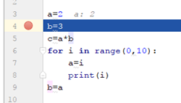
Fig. 16. Setting a breakpoint
When setting a breakpoint, you can also right click on the red circle icon and define a condition that must evaluate to True for the breakpoint to pause the program.
Fig. 17. Defining a conditional breakpoint.
You can set several breakpoints in a program. When the program is paused at a breakpoint, you can allow the program to continue running by selecting Run | Resume Program (F9) from the menu. You can also click on a line to place the cursor on that line, and then select Run | Run to Cursor (Alt+F9) from the menu to allow the program to run up to the line that you selected.

Single stepping
If you want to execute the program line by line to view the values of variables, you can select single stepping, Run | Step Over (F8) to interpret consecutive single lines of code. Note that when the interpreter reaches a function, Step Over will allow the interpreter to execute the contents of the function as a block, and then pause at the line after the function. If you are interested in single stepping into the code in functions, choose Run | Step Into (F7). Step Into can also be used to single step lines outside of functions. It simply dives into function code when it is encountered, whereas Step Over skips the display of the code.
Note that you can do most of your debugging using the F7, F8 and F9 keys (Windows OS). Memorize these: it makes the debugging process much more efficient than continuously visiting the menu.

Assignment Day 5

Write a program to read the names and sequences from a fastA file, and to read the start, stop and translation offset positions of all coding sequences from a gff file, and use the information from the gff file to retrieve the sequence sections and determine the frequencies of all 64 possible codons in the yeast coding sequences.

First, download the files “saccharomyces_cerevisiae_2018.fna” and “saccharomyces_cerevisiae_2018.gff” from SUNlearn, and save it on your computer in the same directory that will contain your Python program file. For example, in “C:\Users\hpatterton\PycharmProjects\helloworld\source\saccharomyces_cerevisiae_2018.fna”. The exact path will be similar, but different, on your computer.
In today’s assignment you will need to define the following three classes and associated class methods:
 | Class | Method
1 | Read_FastA | Read_FastA_Names_And_Sequences(self, filepath)
2 | Read_GFF | Get_Gene_Positions(self, list_of_gff_features, filepath, feature)
3 | My_Codons | Count_Codons(self, sequence, codons, number_of_occurrences, offset=0)

It is not necessary to initialize any data members in any class __init__() method.
The Read_FastA_Names_And_Sequences(self, filepath) method is identical to the function you coded earlier. Simply define the class Read_FastA and add your function as a class method, adding the ‘self’ reference. Alternatively, if your function from earlier did not work properly, you can use the supplied code.
The function should read the names and sequences of the 17 chromosomes of Saccharomyces cerevisiae from the file ‘saccharomyces_cerevisiae_2018.fna’ and return a tuple of two lists sequence_names and sequences, each with 17 string items corresponding to the names and sequences of the 17 chromosomes.
For class ‘Read_GFF’, you need to code the function ‘Get_Gene_Positions(self, list_of_gff_features, filepath, feature)’. Refer to the Appendix to understand the format of a GFF file. Unlike earlier, where you simply stepped though the fastA file line-by-line, testing whether a line started with ‘#’ and then using the whole line if it qualified, the processing you need to do with the GFF file is a bit more involved:
You will need to step though the GFF text line-by-line, filtering and selecting lines that contain information (does not start with the ‘#’ character). You then need to take the usable lines and split it into the 9 items, corresponding to the 9 columns, so that you can work with the data from any single column. You must then retrieve the item from column 2 (index starts at 0) and test whether it equates to ‘CDS’. If it does, you must use the line. If it does not, you must discard the line.
For instance, the first line in the GFF file (open in Notepad++ or Wordpad) that lists a ‘CDS’ feature is:
chrI SGD CDS 335 649 . + 0 Parent=YAL069W_mRNA;Name=YAL069W_CDS;orf_classification=Dubious
Thus, find the lines in the GFF file where column 2 equates to ‘CDS’, and copy the data for seqID, start, end and offset (columns 0, 3, 4 and 7 [blue items]) of the line to a tuple, (chrI,335,649,0), and append that tuple to the list ‘list_of_gff_features’. You do the same for each line where column 2 equates to ‘CDS’. You should end up with a list of approximately 6000 tuples in list_of_gff_features.
TIP
An easy way to split a line into a list composed of the nine items separated by tab characters, is to use the split() command list_of_column_items = gff_line.split(sep='\t'). You can then generate and add the tuple to the list_of_gff_features list with the statement list_of_gff_features.append(list_of_column_items[0], list_of_column_items[3], list_of_column_items[4], list_of_column_items[7]).
The Get_Gene_Positions function also receives the variables filepath and feature, the path to the ‘saccharomyces_cerevisiae_2018.gff’ file, and the string ‘CDS’. We pass ‘CDS’ as a string to the class method in variable feature, so that we can also read lines where the feature equates to gene or mRNA etc., although we will not use these features in this assignment. The function must return the list list_of_gff_features with tuples of CDS information as described above.
Next, the My_Codons class must contain the function Count_Codons(self, sequence, codons, number_of_occurrences, offset=0). This function receives a single DNA sequence from the main body of code (see below), the list of codons generated by the method Make_List_Of_Codons(self), the list number_of_occurrences, which is a list of 64 integers, and offset, which is the offset (gff file column 7) of the CDS. When the program starts, all 64 entries in Number_of_occurrences equals 0. In Count_Codons the number of occurrences of each of the 64 codons are counted in the sequence passed to the method, and these numbers are added to the matching codon entries of number_of_occurrences.
TIP
The code in your function should contain a statement similar to:
Number_of_occurrences += codon_count_for_this_sequence,
where codon_count_for_this_sequence is also a list of 64 integers, corresponding to the number of times that each of the 64 codons were counted in the sequence passed to Count_Codons(). Number_of_occurrences is the cumulative value that will finally contain the tally for all 64 codons counted in all sequences.
Be careful when you count codons! You cannot simply use the string.count(query) function, since it will count all non-overlapping query strings, including the ones out of frame. You want to start at the start+offset defined for the CDS (offset is usually 0), and then count in steps of 3 nucleotides to remain in-frame for the CDS.
TIP
It is likely that you will use a statement similar to:
for start in range(offset,len(sequence),3):

#<<<<<<<<<<<<<<<<<<< COPY CODE BELOW FROM HERE>>>>>>>>>>>>>>>>>>>>
class Read_FastA:

#==================================================================
# This function return a tuple of 2 lists 'sequence_names' and
#'sequences' containing the sequence names and the sequences of the
# entries in the supplied fastA file. There should be no spaces,
# newlines or '>' characters in either 'sequence_names' or
# 'sequences'. Sequence_names must be a list composed of string
# items corresponding to each sequence name sequences must be a
# list of string items, each item corresponding to one sequence
#
# YOU CAN USE YOUR CODE FROM DAY 4, OR THE CODE BELOW
#
#==================================================================

def Read_FastA_Names_And_Sequences(self, filepath):
print("Reading fastA sequences...")
self.sequence_names = []
self.sequences = []
f = open(filepath, 'r')
self.counter = 0
for i in f:
if (i[0] == '>'):
self.counter += 1
self.sequence_names.append(i[1:].replace('\n', ''))
self.sequences.append(str())
else:
self.sequences[self.counter - 1] = self.sequences[self.counter - 1] + i.replace('\n', '')
f.close()
return (self.sequence_names, self.sequences)

class Read_GFF:

def Get_Gene_Positions(self, list_of_gff_features, filepath, feature):
#==================================================================
# This function should be passed a list 'list_of_gff_features' to
# which you append a tuple (seqID, start, end, offset) that
# contains the information from each line from the GFF file
# corresponding to a coding sequences (CDS). Thus, the information
# from the line
# 'chrI SGD CDS 335 649 . + 0
# Parent=YAL069W_mRNA;Name=YAL069W_CDS;orf_classificat...'
# must be appended to the list_of_gff_features as
# ('chrI','335','649','0'). Step through each line of the GFF
# file, selecting only the ones with column 2 == 'CDS', and append
# the seqID, start, end, offset information of each as a tuple to
# 'list_of_gff_features'. Filepath is the full path to the
# 'saccharomyces_cerevisiae_2018.gff' file and feature == 'CDS'
#==================================================================

#******************************************************************
# YOUR CODE GOES HERE
#******************************************************************
return(list_of_gff_features)

class My_Codons:

#==================================================================
# The function generates a list of all possible combinations of 3
# of the 4 nucleotides G, A, T and C, and returns the list as
# 'codons'
#==================================================================

def Make_List_Of_Codons(self):
self.nucleotides = ['G','A','T','C']
self.codons = []
self.tempcodon = ''
for a in self.nucleotides:
for b in self.nucleotides:
for c in self.nucleotides:
self.tempcodon = a+b+c
self.codons.append(self.tempcodon)
return(self.codons)

def Count_Codons(self, sequence, codons, number_of_occurrences, offset=0):

#==================================================================
# The string.count(substring,start,end) method may look like a
# suitable function to use, but it finds the occurrence of a
# substring in ANY FRAME. Codons are arranged in non-overlapping
# groups of three. So we have to begin searching groups of three,
# starting at the beginning of the sequence, taking care of any
# offset defined in the gff file, and then jumping by three bases
# after each comparison. We write our own function to do exactly
# this.
#==================================================================

#******************************************************************
# YOUR CODE GOES HERE
#******************************************************************

return(number_of_occurrences)

#==================================================================
#
# MAIN CODE
#
# This block of code will execute correctly if your functions return
# the data according to the instructions above
#
# DO NOT MODIFY THE CODE BELOW EXCEPT THE FILE PATHS
#
#==================================================================

path_of_gff_file = 'saccharomyces_cerevisiae_2018.gff' # change the path string if yours is different
path_of_fasta_file = 'saccharomyces_cerevisiae_2018.fna' # change the path string if yours is different

# Get the positions and offset of all codings sequences (CDS) in the yeast genome

GFF_file_object = Read_GFF()
list_of_gff_features=[]
total_sequence_length = 0
list_of_gff_features = GFF_file_object.Get_Gene_Positions(list_of_gff_features, path_of_gff_file,'CDS')

# make a list of all 64 possible codons

codon_object = My_Codons()
codons = codon_object.Make_List_Of_Codons()

# Read the chromosome sequences

FASTA_file_object = Read_FastA()
sequence_name, sequences = FASTA_file_object.Read_FastA_Names_And_Sequences(path_of_fasta_file)

# Loop over list_of_gff_features, using one entry at a time

number_of_occurrences =[0]*64
print('Counting codons...')
for gff_line in list_of_gff_features:

# get chromosome and slice the gene sequence of the chromosome with the calculated index
chromosome_sequence = sequences[sequence_name.index(gff_line[0])]
number_of_occurrences = codon_object.Count_Codons(chromosome_sequence[int(gff_line[1])-1:int(gff_line[2])], codons, number_of_occurrences, int(gff_line[3]))

# Print out the total codons
total_codons = sum(number_of_occurrences)
for i in range(0,64):
if(i == 0):
print('Codon','Number','Frequency (/1000)')
print(codons[i],number_of_occurrences[i],1000*number_of_occurrences[i]/total_codons)

#<<<<<<<<<<<<<<<<<<< COPY CODE ABOVE TO HERE>>>>>>>>>>>>>>>>>>>>

Your program output should be similar to the following:
Reading fastA sequences...
Counting codons...
Codon Number Frequency (/1000)
GGG 19582 6.481260214885782
GGA 38383 12.70402465672357
GGT 52540 17.389715641410426
.
.
.
CCA 43695 14.462193090053837
CCT 35146 11.63264076766294
CCC 19864 6.5745967168058

Note: your program will be marked by executing it, using different fastA and gff files to ensure that your code functions properly.
To submit your program, upload your completed, functioning text file to SUNlearn using your student number and a “.py” extention as filename, eg. “2010031648.py”. Your filename must not contain any other characters, spaces or symbols. If your filename format is incorrect, your assignment will not be marked. Make sure your file is functional and can execute as a Python script. If it does not execute correctly, it will not be marked. Do not e-mail your program or submit it as a hard copy. It will not be marked. Programs that are submitted to SUNlearn after the submission deadline will not be marked.
Please be aware of the policies and rules of Stellenbosch University regarding plagiarism when submitting work as your own.
MARKS (25)
Classes and methods are correctly defined (5)
Get_Gene_Positions(list_of_gff_features, filepath, feature) returns correct tuples composed of seqID, start, stop and offset. (10)
Count_Codons(sequence, codons, number_of_occurrences, offset) return correct cumulative number_of_occurrences corresponding to the number of each of the 64 in-frame codons in the test data (10)

Appendix

File formats

fastA
A fastA format file is a text file with a title line for each sequence in the file. The file can contain a single sequence, or multiple sequences. In the latter case each individual sequence is preceded by a title line. The length of each line is not specified, but is usually 80 characters wide (excluding newline characters). Each title line is started with a “>” character. There is no limit on what characters to use in the title line, except that the “>” is reserved as the first character. Using “>” more than once may confuse some parsers.
>sequence_1
GATCGATCGATCGACTGA
>sequence_2
AATTAATTAATTAATTAATT

Note
Each line is terminated with a newline character. On Windows it is represented by the two escapes characters \n\r and on Linux by a single \n. Be aware of this difference.
See en.wikipedia.org/wiki/FASTA_format.

fastQ
This is a text based file of sequences with associated scores for the quality of each nucleotide. It is typically generated with a sequencing apparatus such as manufactures by Illumina or Ion Torrent. The file is composed of units of four lines:
Line 1: starts with the “@” character followed by the name or ID of the sequence
Line 2: the nucleotide sequence
Line 3: starts with a “+” character and may be followed by the sequence name
Line 4: the single letter quality score associated with each nucleotide in the sequence.

An example:
@HWI-ST193:439:D16G8ACXX:4:1101:6038:2128 1:N:0:ATCACG
AGCAGCAATCAGAGATGAAGCCAATGGTGGTCCACGAGCTCCAAATCCTA
+
CCCFFFFFHHHHHJJJJJJJJJJJJJJHHJGIJJJJIJJJJJJIIJJJJI

The sequence name or ID on the first line of the block may also contain additional information. The Illumina sequencing program passes information about the flow cell and sequencing spot position and so forth on this line.
Note: the sequence quality score includes the “@” character, so this character may appear as the first character on line 4. Thus, when parsing, you cannot simply look for the start of the block using the “@” character. You may want to use “@”, skip one line, and then a “+” to positively identify each block of 4 lines.
See: en.wikipedia.org/wiki/FASTQ_format

Generic Feature Format version 3 (GFF3)
GFF3 format is a text file that lists the location of specific features such as genes or exons or replication origins relative to a defined landmark, usually a chromosome. The GFF3 format is widely used by Genome Browsers to display genes, exons etc. as tracks. There are several versions of GFF files with different specifications. Make sure of the version of GFF file that you work with.
GFF3 format text files must start with
##gff-version 3
and may be followed by no or a variable number of comment lines, all starting with a #.
The body of the GFF3 file is composed of 9 tab-separated columns:
Note
In GFF3 format files, characters are escaped with the “%” character, followed by the hexadecimal value of the escaped character. Thus, tab is “%09” (not \t), newline “%0A” (not \n) and carriage return “%0D” (not \r). Some users, such as SGD, does not seem to comply with this specification.
Where information in a column is not available, the entry must be “.”; it cannot be left empty.
- ID
The ID or name of the feature.
- Source
The operating procedure that generated this feature, eg. "Genescan" or a database name, such as "Genbank", etc.
- Type
The type of the feature such as “gene”, “CDS”, “exon”, etc. This is constrained to be either a term from the Sequence Ontology or an SO accession number.
- Start
The start position of the feature relative to the landmark given in column 1. The landmark position starts at index 1 not index 0. Start is always less than or equal to end.
- End
The end position of the feature relative to the landmark given in column 1. The landmark position starts at index 1 not index 0. End is always larger than or equal to Start.
- Score
The score of the feature (sequence similarity, probability; a score defined by the user). A floating point number.
- Strand
The strand of the feature. + for positive strand (relative to the landmark), - for minus strand.
- Phase
Indicates whether the codon start at phase 0,1 or 2 relative to the start of the feature.
- Attributes
A list of feature attributes.
See: github.com/The-Sequence-Ontology/Specifications/blob/master/gff3.md for the full specifications

